Washington State Medicaid Transformation Project Demonstration

Section 1115 Waiver Quarterly Health IT Operational Report

Demonstration Year 2: (January 1, 2018 to December 31, 2018)

Federal Fiscal Quarter: Third Quarter (July 1, 2018 to September 30, 2018)

**Demonstration Year 2 – Quarter 3**

**July 1, 2018 – September 30, 2018**

The Health IT Operational Plan is composed of actionable deliverables to advance the health IT goals and the vision articulated in the Health IT Strategic Roadmap (<https://www.hca.wa.gov/assets/program/health-information-technology-strategic-roadmap.pdf>) in support of Medicaid Transformation in Washington State. The focus of the Health IT Roadmap and Operational Plan aligns with the three phases of work in the Medicaid Transformation Initiative: design, implementation and operations and assessment. The Health IT Operational Plan includes 92 deliverables and tasks in multiple areas including: data, data analytics, data governance, health IT/health information exchange--including the training needs of Accountable Communities of Health (ACHs)--financing, master person identifier, provider directory, and evaluation. This year, 2018, is largely focused on identifying and advancing the data needed by the state, ACHs, and providers, as well as technology tools needed by providers for interoperable health information exchange (HIE) and existing infrastructure projects (i.e., Clinical Data Repository (CDR).

# Success Stories

The Health IT team continued to engage with the ACHs to understand their Health IT capacity, and develop targeted technical assistance to advance their regional projects and ensure Health IT and HIE elements are incorporated. At the end of the third quarter, ACHs submitted their implementation plans to HCA. HCA’s Health IT team reviewed these plans for health IT and health information exchange related elements and have incorporated those pieces into our 2019 plans.

During the third quarter, HCA launched the CDR, allowing providers to access the portal to view clinical and claims data. This effort was focused on physical health providers. The CDR now has more than 5 million successful continuity of care documents. Efforts are underway to increase submissions to and use of the CDR, including supporting behavioral health providers’ use of the CDR.

The Health IT team also spent the third quarter working to integrate the Substance Use Disorder IMD 1115 Waiver elements into our broader Health IT plans. Staff from HCA and Department of Health collaborated to identify tasks to enhance the functionality and use of the prescription drug monitoring program (PDMP). These tasks will be incorporated into our 2019 Health IT Operational Plan and are contingent on identifying and securing needed funds.

The State continues to align the various health IT plans, including the State Medicaid Health IT Plan, which it is currently updating. These efforts are coordinated with a multi-agency enterprise governance group focused on aligning technology investments across the health and human service state agencies for planning and funding purposes. The enterprise governance group has articulated a decision-making process that includes representatives from the Health Care Authority, Department of Health, Department of Social and Health Services, Department of Children, Youth and Families and the Health Benefit Exchange.

# Progress to date

Washington State has made considerable progress in advancing its Health IT Operational Plan, including coordinating with Tribes; disseminating information to ACHs and partners on state and national health information exchange resources; introducing ACHs, providers and others to the CMS supported Health Information Sharing (HIS) assessment, and supporting ACHs in their efforts to assess the health IT/HIE capacities and needs of providers in their region; and continuing the SUD HIE and Consent Management Workgroup.

HCA, in collaboration with DOH, is working to identify several Health IT tasks and deliverables to support implementation of the SUD-HIT plan in the IMD waiver and is incorporating these into the 2019 Health IT Operational Plan. These deliverables focus on identifying funding resources to enhance the PDMP, enhancing the PDMP, and further developing the Health IT infrastructure to facilitate SUD care delivery.

At the end of Q3, HCA completed approximately 85% of all deliverables due in this quarter.

There was one deliverable that remain overdue (discussed further in the challenges section of this report) and there were five items that were re-planned to 2019. The re-planned activities include tasks with deliverables required across all quarters in 2018.



Washington State continues to work on deliverables in all major categories.



# Challenges

While substantial progress has been made there is a one deliverable that is overdue. This deliverable include the following:

|  |  |  |
| --- | --- | --- |
| **Task Number** | **Task** | **Comment** |
| **08-002** | Consider enhancements to current provider license interface with ProviderOne | HCA has been working to advance the creation of a robust state-wide provider directory. These efforts are ongoing and considered high priority by several state agencies. We anticipate that the 2019 Health IT Operational Plan will include tasks related to provider directory.  Several use cases have been identified by HCA and partner agencies. Determinations about connecting the provider licensure system with ProviderOne are pending broader decisions about the creation of a provider directory. |

# Changes in Health IT Operational Plan

There were three items that were re-planned for 2019 due to pending decisions and resource constraints. All five have had their due date moved to the first quarter of 2019:

Task 03-014 (HCA will identify components to pilot the exchange of consent management for 42 CFR part 2) was removed from the 2018 Health IT Operational Plan due to resource constraints. In 2018, resources were used to develop needed educational materials and a consent form to support the exchange of information, subject to 42 CFR Part 2. Contingent on the availability of funds, the 2019 Health IT Operational Plan will include tasks to develop a technical solution to support the electronic exchange (transmit, view, download) of SUD information through the Health Information Exchange and the Clinical Data Repository. If funding is approved, this work is expected to begin in July 2019.

Task 05-020 (HCA will work with OHP to identify EHR tools that do not support ProviderOne IDs) was re-planned because HCA asked One Health Port to focus on launching the CDR instead of focusing on this report.

Task 05-030 (Disseminate security practices white paper). HCA is working to identify the specific elements to feature in a security practices white paper. This paper is currently scheduled to be drafted in the first quarter of 2019. When finalized, it will be disseminated to HCA partners.

Task 02-006 (SAMSHA-HCA will identify and streamline BH reporting requirements). HCA has engaged a contractor and has begun to identify the streamlined data set needed to support behavioral health provider reporting. Work is expected to be completed April 2019.

Task 06-007 (HCA will procure Fraud Abuse Detection System Tools that will be utilized in the Enterprise Data Warehouse database). HCA continues to make progress towards procuring a fraud abuse detection system and is attempting to align this tool with the enterprise data warehouse. A charter has been created for requirements gathering and the initial alignment meeting is scheduled for December 2018.

Clinical Data Repository Monthly ReportPer CMS request, attached to this quarterly report is the most recent monthly CDR status report.

# Next Steps

The State has spent considerable time in the third quarter and early part of the fourth quarter planning for the work to be undertaken in 2019. This includes submitting decision packages for Health IT/HIE related items for consideration by agency leadership and governor’s staff for inclusion in the 2020 Governor’s Budget. (This includes a request for funding to develop an SUD HIE/consent management tool for use in the CDR.) In addition, we are working to develop an SUD HIT Plan (required under the IMD Waiver). Further, we are analyzing the feasibility of PDMP enhancements. Finally, we are working to align the activities of the Health IT Operational plan with the State Medicaid Health IT Plan and other state technology plans. The planning for the 2019 Health IT Operational Plan is ongoing. The anticipated completion date is mid-December 2018. As noted, implementation of several tasks is contingent on funding decisions.

Number of providers submitting to PROD:

* Total Org Parent : 54
* Total Org Child: 22

Please note that the above counts include stand alone parent and child orgs as well as linked parent & child orgs. Some providers are reported at the overall parent organization level and some at the child level (by specific facility/location).

Top 20 organizations by total successful CCD submissions in April

1. University of Washington (87,065)

2. MultiCare facilities (81,793)

3. Providence Health & Services WA (79,892)

4. Swedish First Hill (48,923)

5. Health Point CHC (40,778)

6. Kadlec Regional Medical Center (28,441)

7. Neighborcare Health (27,923)

8. Yakima Neighborhood Health Services (18,434)

9. Confluence Health(13,567)

10. Seattle Childrens (12,449)

11. Community Health Care (11,557)

12. Valley Medical Center (8,220)

13. Tri-Cities Community Health (7,141)

14. The Everett Clinic (6,134)

15. Country Doctor (6,131)

16. Franciscan Health Systems (6000)

17. Pacific Medical Centers (5,819)

18. Family Health Centers (5,274)

19. Valley View Health Center (4,987)

20. Moses Lake Community Health Center (4,518)

Number of provider organizations in UAT in last month: 3

Current time-based extension requests: 64 (final count, no longer accepting extension requests)

CDR tickets at HCA: 5 and CDR tickets at OHP: 15

Please see enclosed maps for further detail:

* Green set of maps: percentage of clients with at least one CCD in their record (by county and by ACH)
* Brown set of maps: percentage of clients with at least one claim in their record (by county and by ACH)
* Blue set of maps: distribution of Medicaid clients across the state (by county and by ACH)

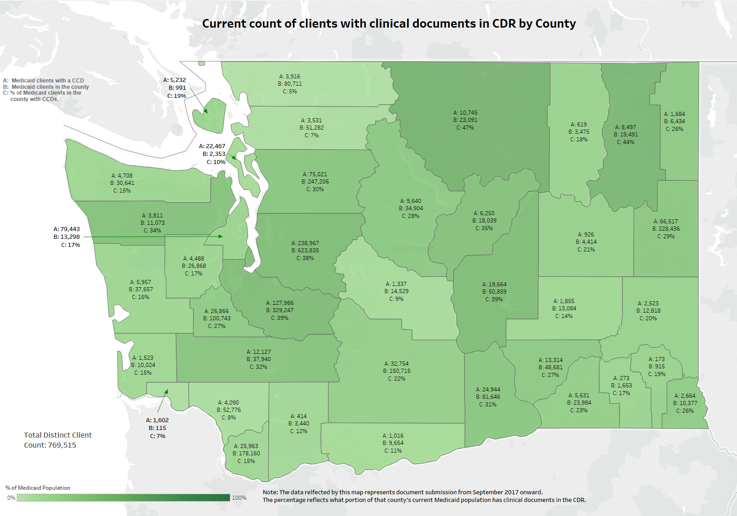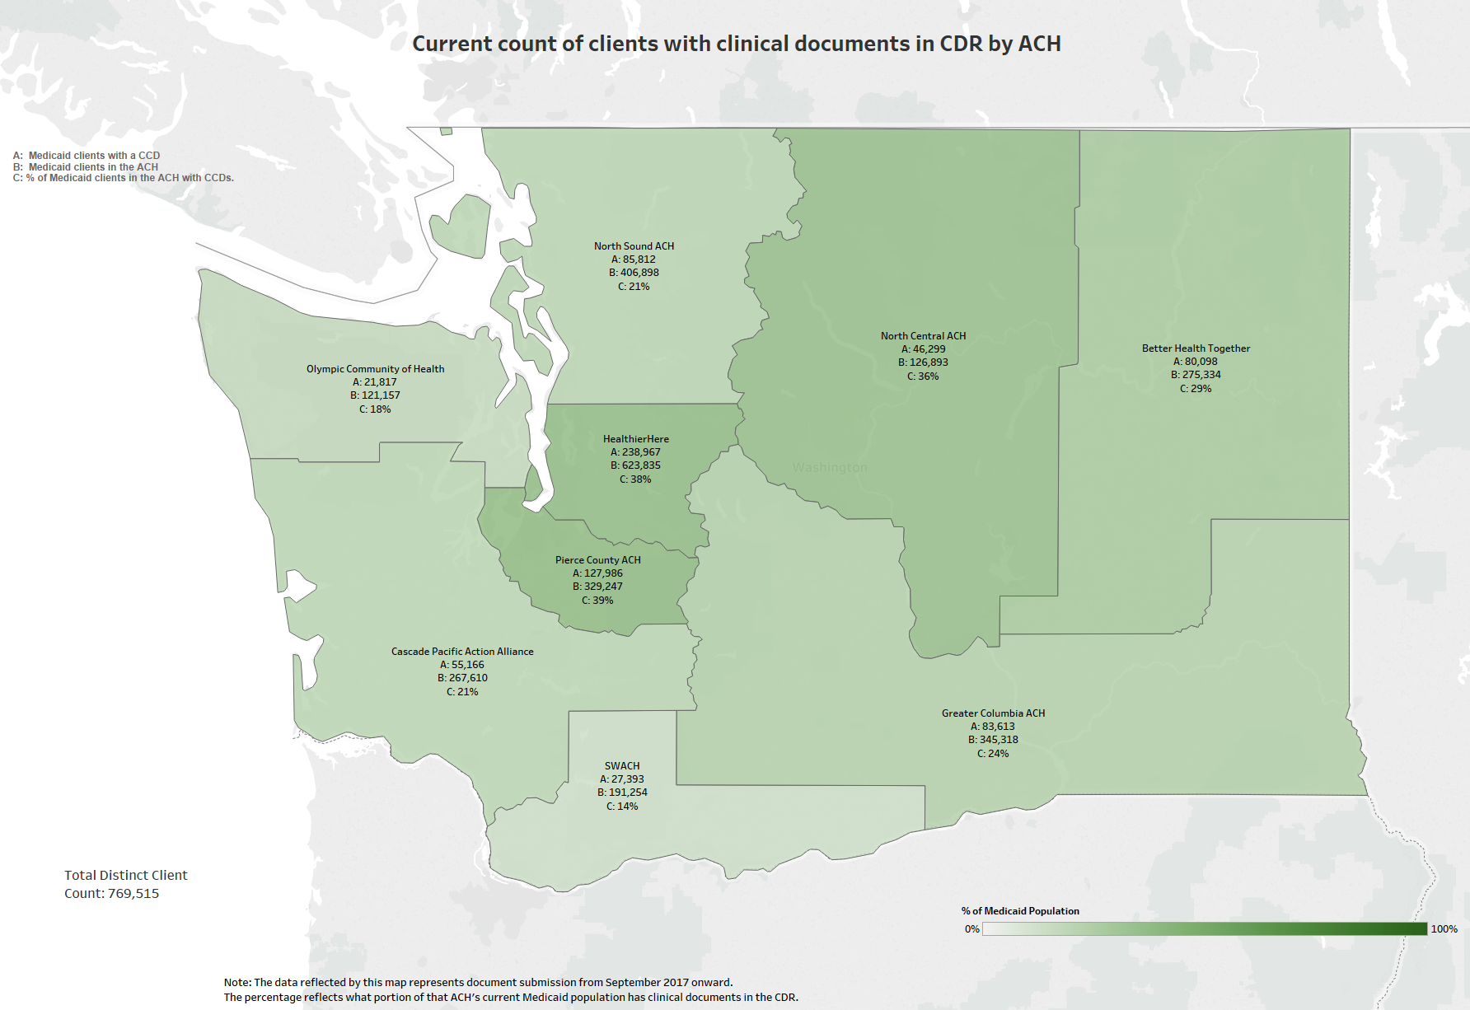

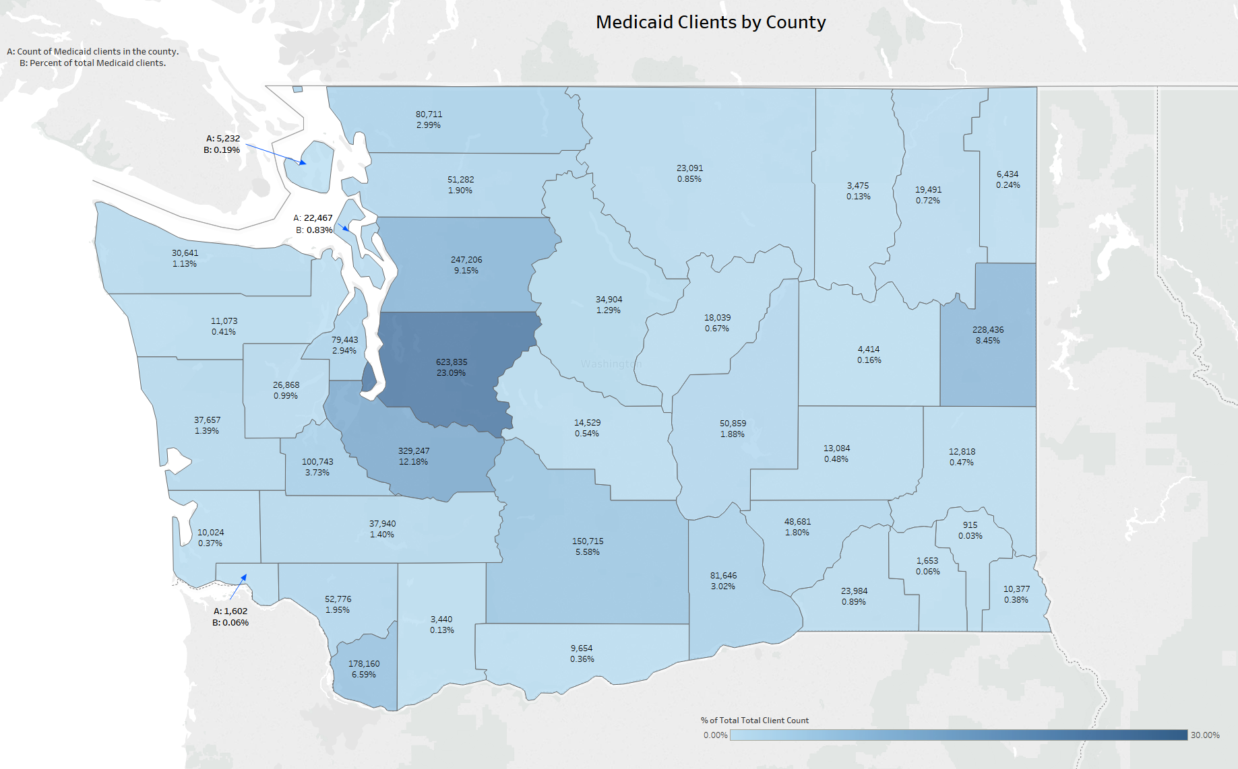

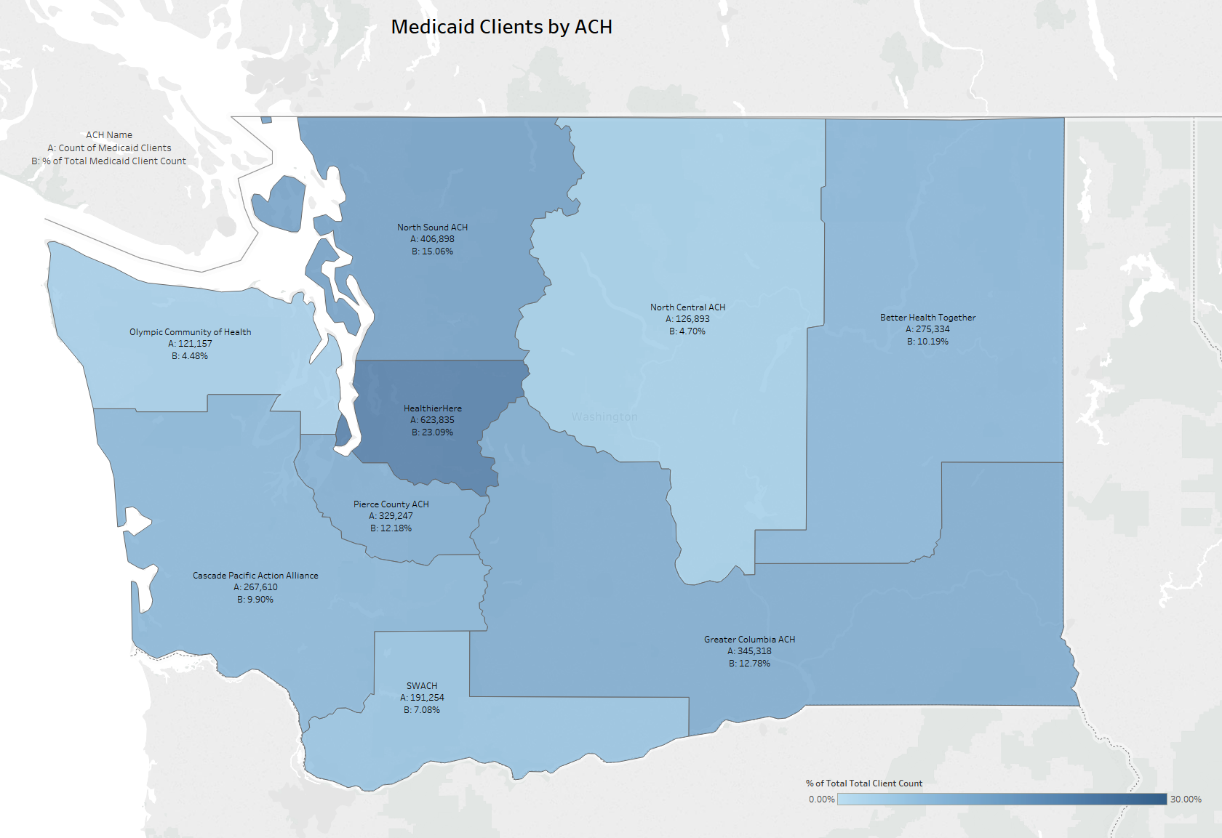

| **Init.** | **% Complete** | **Start** | **End** | **Deliverable Description** | **Qtr** | **Status** | **Category** |
| --- | --- | --- | --- | --- | --- | --- | --- |
| 01-001 | 91.00 | 2/1/18 | 12/31/18 | HIT Operational Plan monthly meetings | Q4 | In Process | Monthly Meetings |
| 02-002 | 54.00 | 10/1/17 | 12/31/18 | Create a list of data sources needed for project implementation | Q4 | In Process | Data |
| 02-003 | 0.00 | 10/1/17 | 12/31/18 | Ensure data inventory will include comprehensive data list | Q2 | In Process | Data |
| 02-004 | 100.00 | 1/1/18 | 7/31/18 | Propose recommended policies, governance and infrastructure changes | Q3 | Complete | Data |
| 02-005 | 100.00 | 4/1/18 | 12/31/18 | HCA will review P1 project artifacts related to whether HCBS providers are HIPAA covered entities | Q4 | Complete | Data |
| 02-006 | 83.00 | 4/1/18 | 12/31/18 | SAMSHA-HCA will identify and streamline BH reporting requirements | Q4 | Replanned | Data |
| 02-008 | 87.00 | 10/1/17 | 12/31/18 | Develop patient/provider attribution approach | Q4 | In Process | Data |
| 03-001 | 100.00 | 10/1/17 | 9/30/18 | HCA will define data aggregation and present options | Q3 | Complete | Data Governance |
| 03-002 | 75.00 | 4/1/18 | 12/31/18 | HCA will support and monitor progress of APCD | Q4 | In Process | Data Governance |
| 03-003 | 0.00 | 4/1/18 | 12/31/18 | HCA will invest in data aggregation in support of payment model 4 | Q4 | In Process | Data Governance |
| 03-004 | 100.00 | 1/1/18 | 12/31/18 | HCA will support master data management | Q4 | Complete | Data Governance |
| 03-005 | 100.00 | 1/1/18 | 12/31/18 | HCA will support Truven/IBM data model-phase 2 | Q3 | Complete | Data Governance |
| 03-006 | 100.00 | 8/1/17 | 3/31/18 | Payment Model 2 analytic support from AIM/RDA | Q4 | Complete | Data Governance |
| 03-007 | 100.00 | 4/1/18 | 4/1/18 | HCA will explore Provider One updates to support FQHC/RHC APM4 | Q4 | Complete | Data Governance |
| 03-008 | 100.00 | 1/1/18 | 12/31/18 | HCA will develop and disseminate data governance guidelines | Q4 | Complete | Data Governance |
| 03-009 | 50.00 | 1/1/18 | 12/31/18 | HCA will support ACHs in adhering to HCA data governance guidelines | Q4 | In Process | Data Governance |
| 03-010 | 100.00 | 10/1/17 | 3/31/18 | HCA and DSHS will consult with SAMHSA on 42 CFR Part 2 | Q1 | Complete | Data Governance |
| 03-011 | 100.00 | 10/1/17 | 3/31/18 | HCA will collaborate with ONC on state collaborative for SUD and other sensitive information | Q2 | Complete | Data Governance |
| 03-012 | 100.00 | 1/1/18 | 6/30/18 | HCA will encourage other state agencies to participate in ONC state learning collaborative | Q4 | Complete | Data Governance |
| 03-013 | 100.00 | 1/1/18 | 9/30/18 | HCA will share information about consent management of sensitive/SUD information | Q4 | Complete | Data Governance |
| 03-014 | 50.00 | 7/1/18 | 3/31/19 | HCA will identify components to pilot the exchange of consent management for 42 CFR part 2 | Q1 | Replanned | Data Governance |
| 03-015 | 50.00 | 1/1/18 | 12/31/18 | Develop DSAs that adhere to state and agency policies for data governance | Q1 | In Process | Data Governance |
| 03-016 | 100.00 | 4/1/18 | 6/30/18 | Consult with ONC to understand 21st century cures act | Q2 | Complete | Data Governance |
| 03-017 | 82.00 | 4/1/18 | 12/31/18 | Statewide DSA strategy complete | Q4 | In Process | Data Governance |
| 03-019 | 100.00 | 7/1/18 | 9/30/18 | HCA will encourage ACHs to partner with jails and corrections to ease burdens at transition | Q3 | Complete | Data Governance |
| 04-001 | 72.00 | 11/1/17 | 12/31/18 | HCA will build out dashboards for Medicaid standard reporting | Q4 | In Process | Data Analytics |
| 04-002 | 100.00 | 10/1/17 | 3/31/18 | HCA will create analytic ready data products | Q2 | Complete | Data Analytics |
| 05-001 | 50.00 | 10/1/17 | 12/31/18 | HIT/HIE assessment strategy complete | Q4 | In Process | HIT/Health Information Exchange |
| 05-002 | 100.00 | 10/1/17 | 7/31/18 | Determine scope and results of HIT/HIE assessments of providers in ACHs | Q3 | Complete | HIT/Health Information Exchange |
| 05-003 | 100.00 | 1/1/18 | 3/31/18 | Introduce ACHs, providers and other to CMS Health information sharing assessment | Q4 | Complete | HIT/Health Information Exchange |
| 05-004 | 100.00 | 1/1/18 | 9/30/18 | If needed, HCA will support ACHs in assessing provider HIT capacity | Q1 | Complete | HIT/Health Information Exchange |
| 05-005 | 100.00 | 1/1/18 | 7/31/18 | Explore HIT/HIE solutions to address barriers/gaps in ACH projects | Q4 | Complete | HIT/Health Information Exchange |
| 05-006 | 100.00 | 1/1/18 | 3/31/18 | Participate in round table discussions with tribal governments | Q3 | Complete | HIT/Health Information Exchange |
| 05-007 | 100.00 | 1/1/18 | 6/30/18 | Provide a presentation on HIE to tribal government leaders | Q1 | Complete | HIT/Health Information Exchange |
| 05-008 | 100.00 | 10/1/17 | 3/15/18 | HCA will consult with tribal government leaders to understand concerns related to privacy issues and identify solutions to address concerns | Q3 | Complete | HIT/Health Information Exchange |
| 05-009 | 100.00 | 10/1/17 | 12/31/17 | Tribes and IHCP will submit a IHCP planning funds plan for statewide improvement in AI/AN behavioral health | Q3 | Complete | HIT/Health Information Exchange |
| 05-010 | 100.00 | 1/1/18 | 9/30/18 | HCA and tribal governments will consult and collaborate on HIE and PHM activities | Q1 | Complete | HIT/Health Information Exchange |
| 05-011 | 100.00 | 1/1/18 | 6/30/18 | HCA and ACHs will identify shared HIT/HIE care coordination tools, funding for HIE tools, and shared contracts/contracting language | Q2 | Complete | HIT/Health Information Exchange |
| 05-012 | 100.00 | 4/1/18 | 9/30/18 | HCA will pursue 10% matching funding to support HIT/HIE assessment activities | Q3 | Complete | HIT/Health Information Exchange |
| 05-013 | 100.00 | 1/1/18 | 3/31/18 | HCA will explore CRM tool for ACHs | Q1 | Complete | HIT/Health Information Exchange |
| 05-015 | 0.00 | 4/1/18 | 12/31/18 | HCA will design and disseminate a quarterly report by provider and MCO that shows progress in who is using the CDR | Q3 | In Process | HIT/Health Information Exchange |
| 05-016 | 0.00 | 10/1/17 | 12/31/18 | HCA will convene a clinical group to provide guidance/feedback on the type and format of info in CDR | Q2 | In Process | HIT/Health Information Exchange |
| 05-017 | 75.00 | 10/1/17 | 12/31/18 | FHCQ will lead effort to create "high priority" use cases for CDR | Q3 | Complete | HIT/Health Information Exchange |
| 05-018 | 100.00 | 4/1/18 | 9/30/18 | HCA will convene group to prioritize CDR needs to meet the Medicaid transformation | Q1 | Complete | HIT/Health Information Exchange |
| 05-019 | 100.00 | 1/1/18 | 9/30/18 | HCA and OHP will develop a catalog of OHP services, provider types registered, and future services | Q4 | Complete | HIT/Health Information Exchange |
| 05-020 | 25.00 | 1/1/18 | 3/31/19 | HCA will work with OHP to identify EHR tools that do not support ProviderOne IDs | Q4 | Replanned | HIT/Health Information Exchange |
| 05-021 | 100.00 | 1/1/18 | 7/31/18 | HCA will work with OHP to launch CDR provider portal | Q4 | Complete | HIT/Health Information Exchange |
| 05-022 | 100.00 | 10/1/18 | 12/31/18 | HCA will consider the need to provide individual level access to health information | Q3 | Complete | HIT/Health Information Exchange |
| 05-023 | 91.00 | 2/1/18 | 12/31/18 | Monthly TA meetings | Q3 | In Process | HIT/Health Information Exchange |
| 05-024 | 100.00 | 1/1/18 | 6/30/18 | Identify TA topics | Q2 | Complete | HIT/Health Information Exchange |
| 05-025 | 100.00 | 1/1/18 | 6/30/18 | Determine TA activities by QUALIS | Q3 | Complete | HIT/Health Information Exchange |
| 05-026 | 100.00 | 7/1/18 | 9/30/18 | HCA will consider needs to implement alternative TA and training support models to assist providers | Q4 | Complete | HIT/Health Information Exchange |
| 05-027 | 100.00 | 7/1/18 | 9/30/18 | HCA and ACHs will explore engaging private philanthropic organizations | Q4 | Complete | HIT/Health Information Exchange |
| 05-028 | 0.00 | 7/1/18 | 12/31/18 | HCA annual HIT/HIE roadshow | Q2 | In Process | HIT/Health Information Exchange |
| 05-029 | 0.00 | 7/1/18 | 12/31/18 | Contract for white paper describing best security practices for HIT/HIE | Q2 | In Process | HIT/Health Information Exchange |
| 05-030 | 0.00 | 4/1/18 | 3/31/18 | Disseminate security practices white paper | Q4 | Replanned | HIT/Health Information Exchange |
| 05-031 | 50.00 | 4/1/18 | 12/31/18 | Identify performance measures related to adoption of HIT/HIE | Q3 | Complete | HIT/Health Information Exchange |
| 05-032 | 50.00 | 7/1/18 | 12/31/18 | Share HIT/HIE performance measures with independent evaluator | Q4 | Complete | HIT/Health Information Exchange |
| 05-033 | 100.00 | 7/1/18 | 9/30/18 | Disseminate performance measures | Q4 | Complete | HIT/Health Information Exchange |
| 05-034 | 75.00 | 4/1/18 | 12/31/18 | HCA will explore methods with MCOs to encourage provider use of HIE technologies | Q4 | In Process | HIT/Health Information Exchange |
| 05-035 | 100.00 | 10/1/17 | 12/31/18 | HCA will compile and disseminate contact list | Q4 | Complete | HIT/Health Information Exchange |
| 05-036 | 50.00 | 2/3/18 | 12/31/18 | ONC quarterly updates | Q4 | In Process | HIT/Health Information Exchange |
| 05-037 | 40.00 | 10/1/17 | 12/31/18 | Reporting to federal government | Q3 | In Process | HIT/Health Information Exchange |
| 06-001 | 100.00 | 4/1/18 | 6/30/18 | HCA will identify 90/10 funding sources | Q4 | Complete | Financing |
| 06-002 | 36.00 | 10/1/17 | 12/31/18 | HCA will pursue funding sources to meet HIT needs | Q4 | In Process | Financing |
| 06-002 | 100.00 | 4/1/18 | 6/30/18 | HCA will seek federal guidance on 10% match | Q4 | Complete | Financing |
| 06-003 | 0.00 | 1/1/18 | 12/31/18 | HCA will actively explore opportunities to leverage 90/10 match | Q4 | In Process | Financing |
| 06-004 | 0.00 | 4/1/18 | 12/31/18 | If needed identify a legislative strategy | Q4 | In Process | Financing |
| 06-005 | 0.00 | 4/1/18 | 12/31/18 | identify opportunities for shared HIT financial investments | Q4 | In Process | Financing |
| 06-006 | 0.00 | 1/1/18 | 12/31/18 | HCA will support identified funding requests | Q2 | In Process | Financing |
| 06-007 | 50.00 | 1/1/18 | 3/31/18 | HCA will procure Fraud Abuse Detection System tools for EDW | Q4 | Replanned | Financing |
| 07-001 | 100.00 | 1/1/18 | 6/30/18 | HCA will discuss options and authority to advance master patient identifier | Q4 | Complete | Master Person Identifier |
| 07-002 | 0.00 | 10/1/18 | 12/31/18 | If appropriate, HCA will pursue 90/10 funding to implement master patient identifier | Q4 | In Process | Master Person Identifier |
| 08-001 | 100.00 | 10/1/17 | 12/31/18 | Determine feasibility of using 90/10 funding for provider directory tasks | Q4 | Complete | Provider Directory |
| 08-002 | 50.00 | 10/1/17 | 7/31/18 | Consider enhancements to current provider license interface with ProviderOne | Q2 | Overdue | Provider Directory |
| 08-003 | 43.00 | 7/1/18 | 12/31/18 | HCA, will identify provider directory use cases | Q2 | In Process | Provider Directory |
| 08-003 | 100.00 | 7/1/18 | 12/31/18 | Master Data Management provider files from Truven have been created | Q4 | Complete | Provider Directory |
| 08-003 | 100.00 | 7/1/18 | 12/31/18 | Procured list of PCPs | Q4 | Complete | Provider Directory |
| 08-003 | 100.00 | 7/1/18 | 12/31/18 | Cat 1 Provider data files in Excel form are available to ACHs in box.com | Q3 | Complete | Provider Directory |
| 08-003 | 0.00 | 7/1/18 | 12/31/18 | Determine resources to complete the tasks | Q4 | In Process | Provider Directory |
| 08-003 | 0.00 | 7/1/18 | 12/31/18 | Developing understanding of what is available in the master data management | Q4 | In Process | Provider Directory |
| 08-003 | 0.00 | 7/1/18 | 12/31/18 | Complete ashboard using the provider data file for the ACHs | Q4 | In Process | Provider Directory |
| 08-003 | 0.00 | 7/1/18 | 12/31/18 | Communicate availability of the Cat 1 provider files | Q4 | In Process | Provider Directory |
| 09-001 | 0.00 | 7/1/18 | 12/31/18 | HCA will present to leadership approaches for displaying P4P measures and means to explore sub-populations | Q4 | In Process | Data Visualization |
| 09-002 | 0.00 | 10/1/18 | 12/31/18 | HCA (if appropriate) will determine costs of data visualization and identify funding sources | Q4 | In Process | Data Visualization |
| 10-001 | 83.00 | 2/1/18 | 12/31/18 | An independent evaluation of Health IT/HIE activities will be conducted in accordance with evaluation protocol | Q4 | In Process | Project Evaluation |
| 10-002 | 0.00 | 10/1/18 | 12/31/18 | Share independent evaluation results | Q4 | In Process | Project Evaluation |