

Washington State Medicaid Transformation Project demonstration

Section 1115 Waiver Quarterly Health IT Operational Report

Demonstration Year 2: (January 1, 2018 to December 31, 2018)

Federal Fiscal Quarter: Fourth Quarter (October 1, 2018 to December 31, 2018)

# Demonstration Year 2 – Quarter 4 October 1, 2018 – December 31, 2018

The Health IT Operational Plan is composed of actionable deliverables to advance the health IT goals and vision articulated in the Health IT Strategic Roadmap (<https://www.hca.wa.gov/assets/program/health-information-technology-strategic-roadmap.pdf>). This work supports the Healthier Washington Medicaid Transformation (Transformation) in Washington State. The Health IT Roadmap and Operational Plan focuses on three phases of Transformation work: design, implementation and operations, and assessment. The Health IT Operational Plan includes 92 deliverables and tasks in areas including:

* Data, data analytics, data governance
* Health IT/health information exchange, including related training for the Accountable Communities of Health (ACHs)
* Financing
* Master person identifier
* Provider directory
* Evaluation.

In 2018, the work focused on identifying and providing the data needed by the state, ACHs, and providers, as well as supporting technology tools needed by providers for interoperable health information exchange (HIE) and existing infrastructure projects (e.g., Clinical Data Repository (CDR)).

# Success Stories

The Washington State Health Care Authority (HCA) spent much of the 2018 fourth quarter finalizing the 2019 Health IT Operational Plan. This involved working with HCA leadership and Department of Health (DOH) leaders and staff, and with the ACHs. We submitted the 2019 Health IT Operational Plan to CMS on January 3, 2019.

The Health IT team spent much of the fourth quarter focused on integrating the tasks in the Substance Use Disorder (SUD) Health IT Plan (a required component of the IMD 1115 Waiver) into our broader Health IT plans. This is a required component of the IMD 1115 waiver. Staff from HCA and DOH defined functionality and use of the prescription drug monitoring program (PDMP). This included exploring funding sources. Of particular interest is how certain provisions in the SUPPORT Act align with tasks in the SUD Health IT Plan, and could be used in Washington State to support our efforts. While we await federal guidance on the SUPPORT Act, the Health IT team has conducted a financial mapping exercise to document potential funding sources for the required tasks in the SUD Health IT Plan. Task 1 in the SUD Health IT Plan requires completing a financial map to identify resources that could be used to support the tasks in the SUD Health IT Plan. We submitted that deliverable to CMS on January 17, 2019.

HCA continues to add individuals into the CDR. The CDR now contains more than 7.5 million “continuity of care documents”. It averages over 500,000 “continuity of care documents” per month. HCA continued encouraging providers to submit documents to the CDR, and is now reaching out to behavioral health providers.

The state continues to align the various health IT plans, including the State Medicaid Health IT Plan, which it is currently updating. These efforts are coordinated with a multi-agency enterprise governance group. This group aligns technology investments of state health and human service agencies for planning and funding purposes. The enterprise governance group has begun prioritizing multi-agency projects to ensure coordination and resource alignment.

# Progress to date

During 2018, Washington State substantially advanced its Health IT Operational Plan. This work included:

* Coordinating with Tribes and ACHs on state and national HIE resources.
* Continuing the SUD HIE and Consent Management Workgroup.
* Aligning HIE elements into the Medicaid Transformation’s Independent External Evaluation.
* Developing a financial mapping tool for the SUD-IMD Health IT required projects.

HCA, in collaboration with DOH:

* Identified Health IT tasks and deliverables needed to implement  the SUD Health IT plan in the IMD waiver.
* Incorporated these tasks into the 2019 Health IT Operational Plan.

These deliverables identify funding resources to enhance the Prescription Drug Monitoring Program (PDMP) and further develop the Health IT infrastructure for SUD care delivery.

By the end of 2018, HCA had completed approximately 93% of all deliverables due in this year. Three deliverables remain at risk (see the challenges section of this report) and three items re-planned to 2019. The re-planned items include tasks with deliverables required in all quarters in 2018.



Washington State continues to work on deliverables in all major categories.



# Challenges

While substantial progress has been made, there are two deliverables that are at-risk, and six that were re-planned for 2019. These include the following at-risk deliverables:

|  |  |  |
| --- | --- | --- |
| **Task Number** | **Task** | **Comment** |
| **02-006** | SAMSHA-HCA will identify and streamline BH reporting requirements | HCA is currently working to advance to advance BH reporting requirements and has contracted with project management support to advance this work. Work is underway and is scheduled to complete in April 2019. |
| **03-003** | HCA will invest in data aggregation in support of payment model 4 | HCA is currently evaluating the success of the Payment Model 4 test and it is unclear whether there will be a need to support data aggregation for this payment model going forward. |
|  |  |  |

# Changes in Health IT Operational Plan

There were six items that were re-planned for 2019 due to pending decisions and resource constraints. All six are due in the first quarter of 2019:

Task 02-008 *(Develop patient/provider attribution approach)*. HCA identified several different attribution approaches currently at use by state agencies and Medicaid Managed Care Organizations. HCA convened a workgroup to review these attribution methodologies and determine whether a single approach is appropriate. If so, this group will be tasked with recommending a singular attribution approach. This work will continue throughout 2019.

Task 03-014 *(HCA will identify components to pilot the exchange of consent management for 42 CFR part 2)*

This task was removed from the 2018 Health IT Operational Plan due to resource constraints. In 2018, resources were used to develop needed educational materials and an exchange of information consent form, subject to 42 CFR Part 2. Educational materials and sample consent form will be disseminated by the end of March 2019.

In addition, and if funds allow, the 2019 Health IT Operational Plan will include development of a technical solution for the electronic exchange (transmit, view, download) of SUD information through the statewide HIE and the CDR. If funding is approved, this work is expected to begin in July 2019.

Task 05-020 *(HCA will work with OneHealthPort (OHP) to identify EHR tools that do not support ProviderOne IDs)*

This task was re-planned because HCA asked OHP to focus on launching the CDR instead of focusing on this report.

Task 05-029 *(Contract of white paper describing best security practices for HIT/HIE)* This work has been re-planned to be completed by the end of Q2 2019.

Task 05-030 *(Disseminate security practices white paper)*

HCA is working to identify the specific elements to feature in a security practices white paper. This paper is scheduled to be drafted in the first quarter of 2019. When done, it will be shared with HCA partners.

Task 06-007 *(HCA will procure Fraud Abuse Detection System Tools for use in the Enterprise Data Warehouse database)*

HCA is making progress in procuring a fraud abuse detection system to align with the enterprise data warehouse. HCA has created a charter for gathering requirements, and initial meetings have occurred.

# Next Steps

HCA is implementing the 2019 Health IT Operational Plan. As noted, implementation of several tasks is contingent on funding decisions. We are continuing to align the Health IT Operational Plan with the State Medicaid Health IT Plan (SMHP) and other state technology plans. We plan to complete aligning the SMHP with the Health IT Operational Plan and other state technology plans by the end of April 2019.

Top 20 Organizations by total successful CCD submissions

|  |  |  |  |  |  |
| --- | --- | --- | --- | --- | --- |
| Rank | Org Name | CCD Count | Rank | Org Name | CCD Count |
| 1. | University of Washington | 77,318 | 11. | Seattle Childrens | 13,975 |
| 2. | MultiCare | 67,344 | 12. | The Vancouver Clinic | 11,902 |
| 3. | Providence Health & Services | 64,923 | 13. | Community Health Care | 11,465 |
| 4. | Swedish First Hill | 41,375 | 14. | Confluence Health | 10,681 |
| 5. | Tri-Cities Community Health | 37,394 | 15. | Valley Medical Center | 6,851 |
| 6. | Health Point CHC | 32,478 | 16. | The Everett Clinic | 5,376 |
| 7. | Neighborcare Health | 23,895 | 17. | Country Doctor | 5,116 |
| 8. | Kadlec Regional Medical Center | 21,365 | 18. | Pacific Medical Center | 4,587 |
| 9. | Yakima Neighborhood Health | 15,250 | 19. | Valley View Health Center | 4,537 |
| 10. | PeaceHealth | 14,919 | 20. | Moses Lake Community Health | 4,356 |

Number of Provider Organizations in UAT in last month: 6

CDR Tickets at HCA:3 and CDR Tickets at OHP: 9

Map showing clients by county 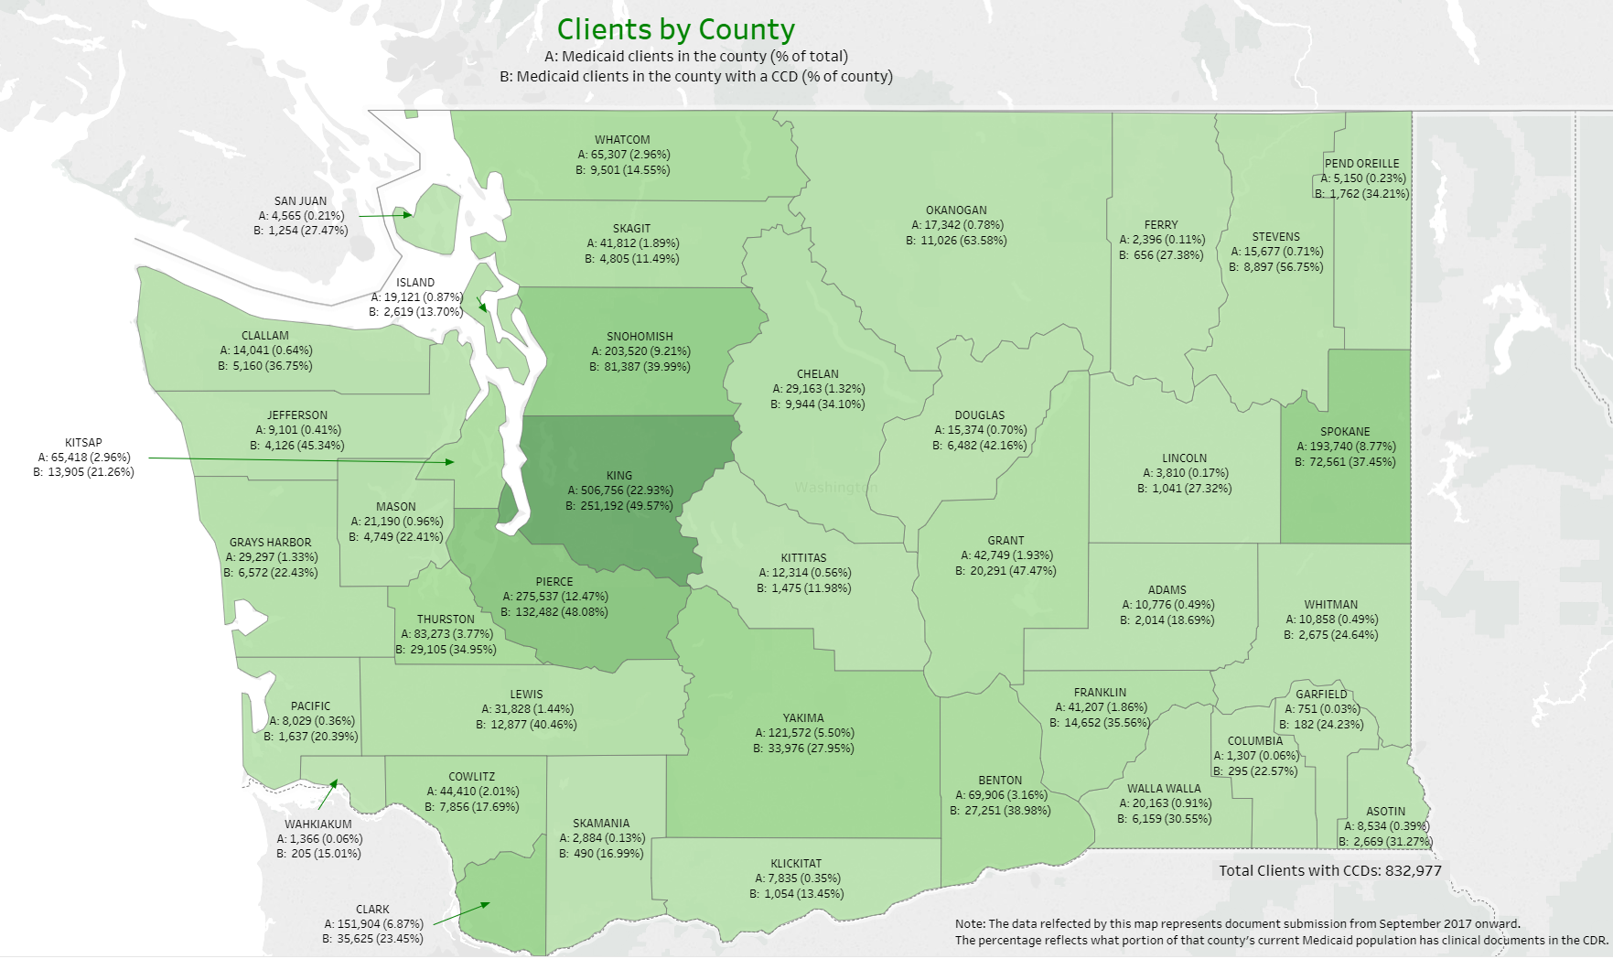

Map showing clients by ACH 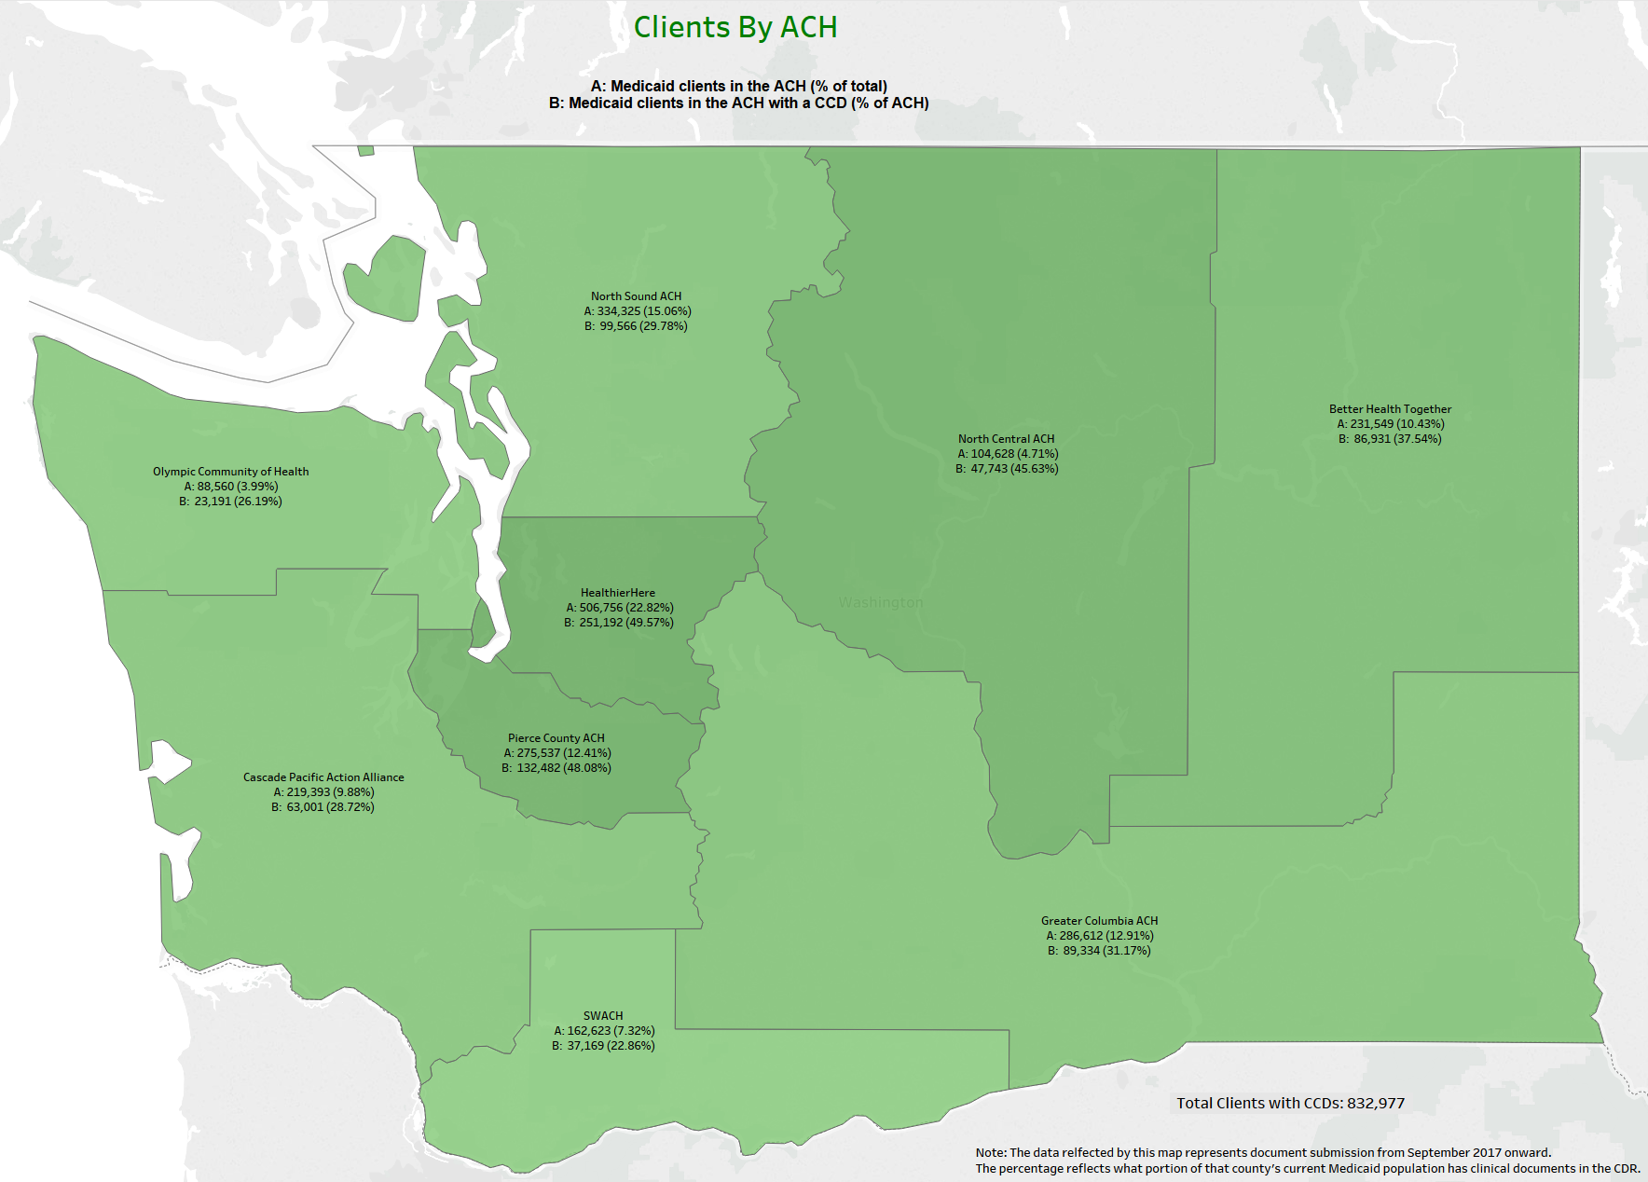

Map showing clients with claims by county 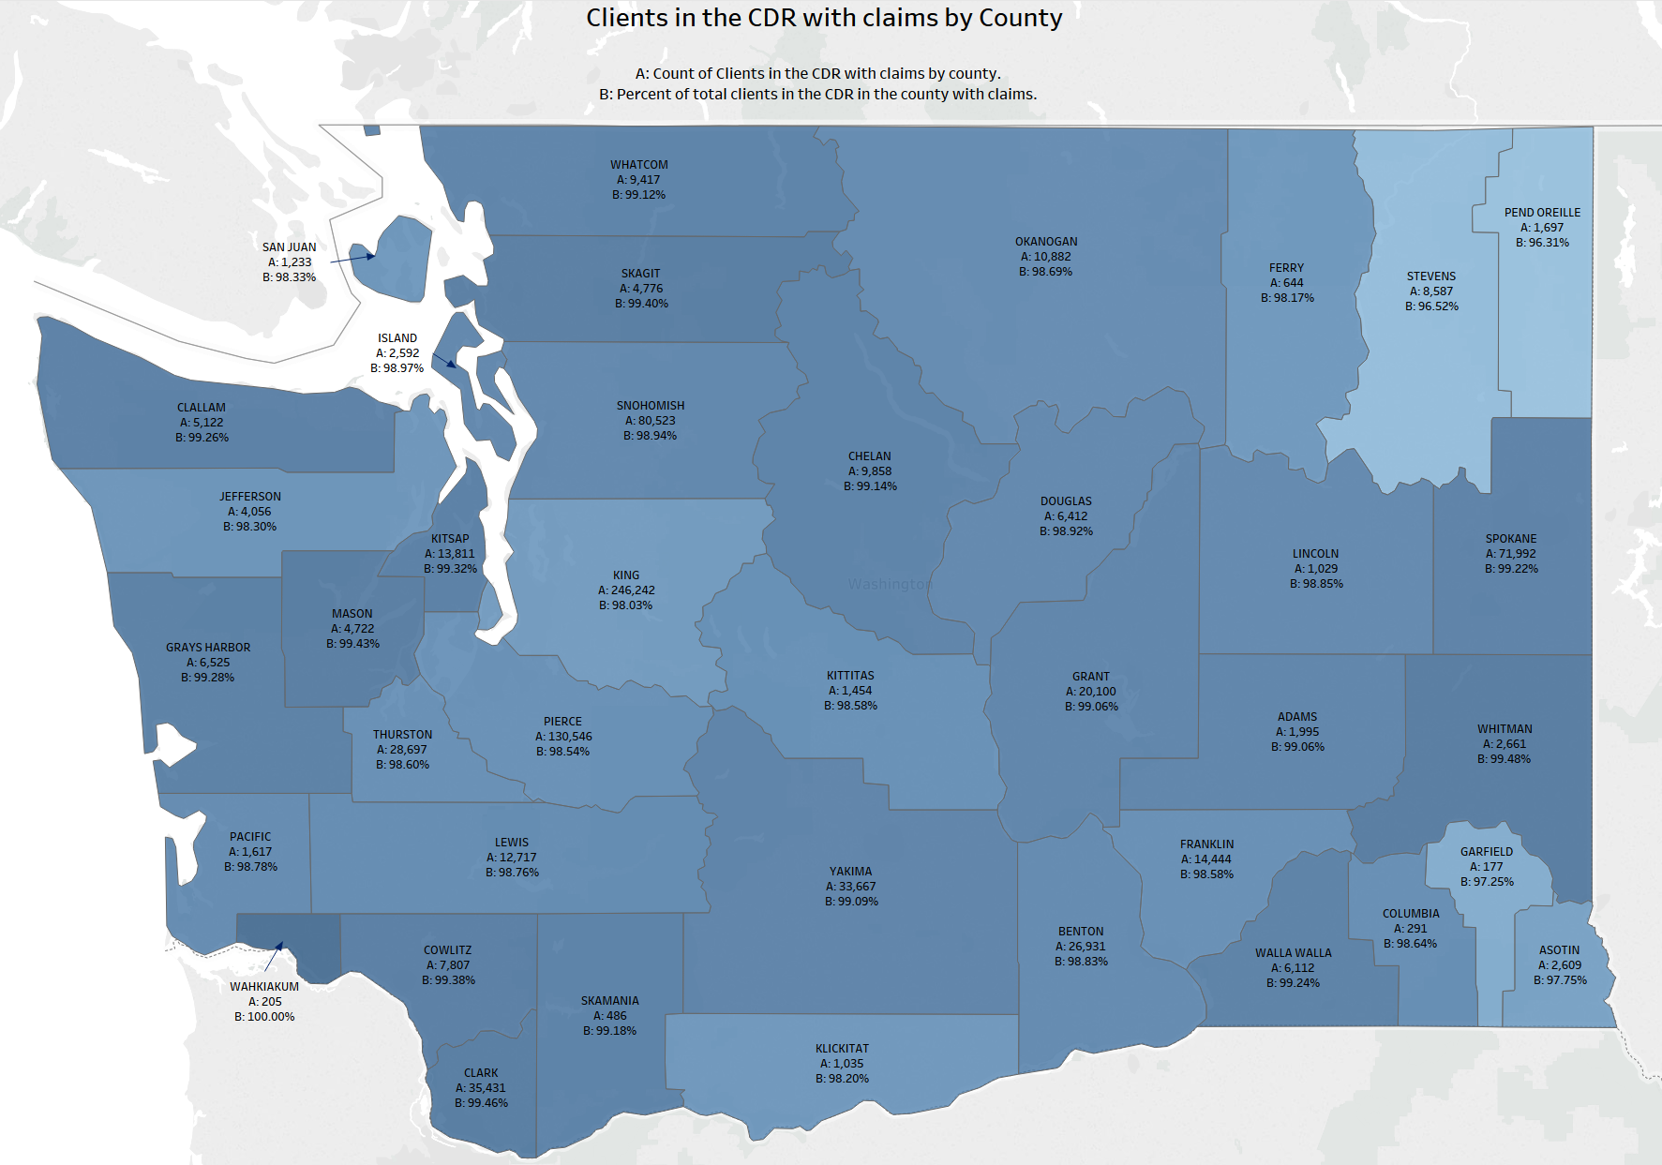

Map showing clients with claims by ACH

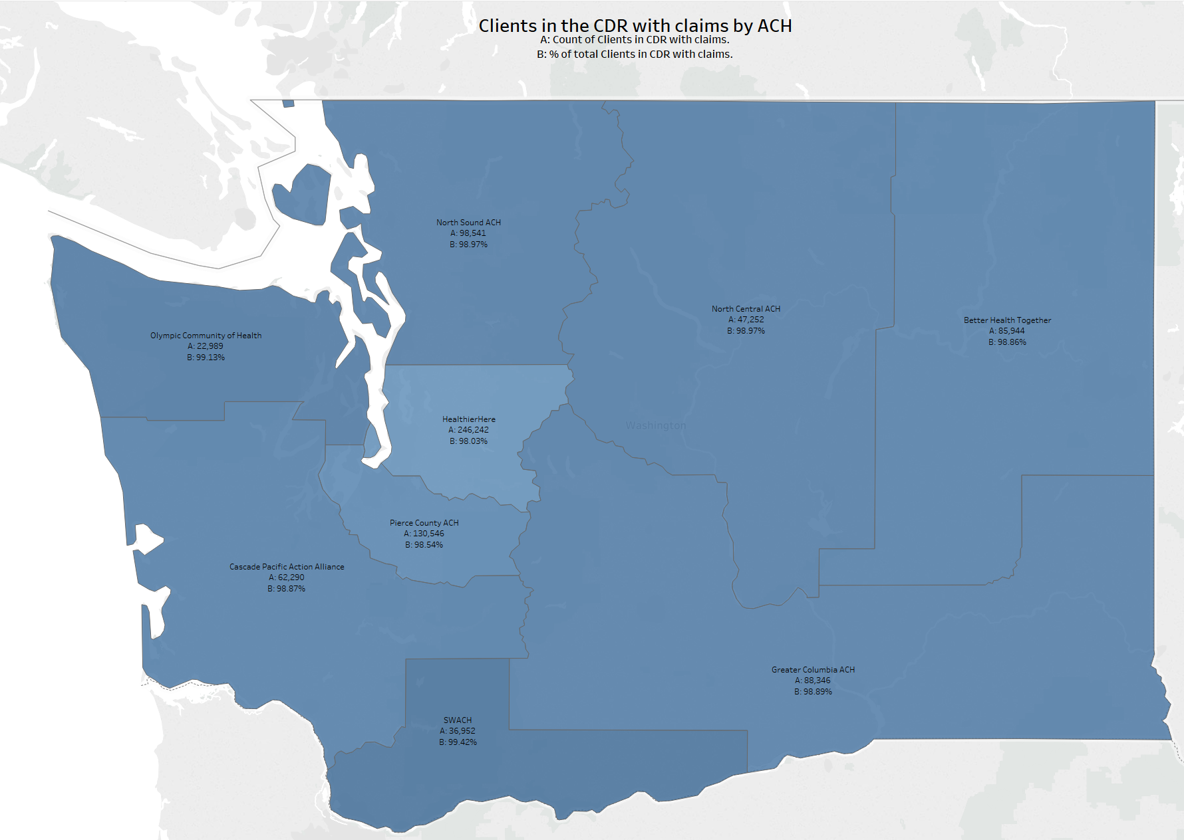

| **Init.** | **% Complete** | **Start** | **End** | **Deliverable Description** | **Qtr** | **Status** | **Category** |
| --- | --- | --- | --- | --- | --- | --- | --- |
| 01-001 | 100 | 02/01/18 | 12/31/18 | HIT Operational Plan monthly meetings | Q4 | Complete | Monthly Meetings |
| 02-002 | 100 | 10/02/17 | 12/31/18 | Create a list of data sources needed for project implementation | Q4 | Complete | Data |
| 02-003 | 100 | 10/02/17 | 12/31/18 | Ensure data inventory will include comprehensive data list | Q4 | Complete | Data |
| 02-004 | 100 | 01/01/18 | 07/31/18 | Propose recommended policies, governance and infrastructure changes | Q3 | Complete | Data |
| 02-005 | 100 | 04/02/18 | 12/31/18 | HCA will review P1 project artifacts related to whether HCBS providers are HIPAA covered entities | Q4 | Complete | Data |
| 02-006 | 83 | 04/02/18 | 12/31/18 | SAMSHA-HCA will identify and streamline BH reporting requirements | Q4 | At Risk | Data |
| 02-008 | 94 | 10/02/17 | 12/31/18 | Develop patient/provider attribution approach | Q4 | Replanned | Data |
| 03-001 | 100 | 10/02/17 | 09/28/18 | HCA will define data aggregation and present options | Q3 | Complete | Data Governance |
| 03-002 | 100 | 04/02/18 | 12/31/18 | HCA will support and monitor progress of APCD | Q4 | Complete | Data Governance |
| 03-003 | 75 | 04/02/18 | 12/31/18 | HCA will invest in data aggregation in support of payment model 4 | Q4 | At Risk | Data Governance |
| 03-004 | 100 | 01/01/18 | 12/31/18 | HCA will support Master Data management | Q4 | Complete | Data Governance |
| 03-005 | 100 | 01/01/18 | 12/31/18 | HCA will support Truven/IBM data model-phase 2 | Q4 | Complete | Data Governance |
| 03-006 | 100 | 08/01/17 | 03/30/18 | Payment Model 2 analytic support from AIM/RDA | Q1 | Complete | Data Governance |
| 03-007 | 100 | 04/02/18 | 04/06/18 | HCA will explore Provider One updates to support FQHC/RHC APM4 | Q2 | Complete | Data Governance |
| 03-008 | 100 | 01/01/18 | 12/31/18 | HCA will develop and disseminate data governance guidelines | Q4 | Complete | Data Governance |
| 03-009 | 100 | 01/01/18 | 12/31/18 | HCA will support ACHs in adhering to HCA data governance guidelines | Q4 | Complete | Data Governance |
| 03-010 | 100 | 10/02/17 | 03/30/18 | HCA and DSHS will consult with SAMHSA on 42 CFR Part 2 | Q1 | Complete | Data Governance |
| 03-011 | 100 | 10/02/17 | 03/30/18 | HCA will collaborate with ONC on state collaborative for SUD and other sensitive information | Q1 | Complete | Data Governance |
| 03-012 | 100 | 01/01/18 | 06/29/18 | HCA will encourage other state agencies to participate in ONC state learning collaborative | Q2 | Complete | Data Governance |
| 03-013 | 100 | 01/01/18 | 09/28/18 | HCA will share information about consent management of sensitive/SUD information | Q3 | Complete | Data Governance |
| 03-014 | 50 | 07/02/18 | 03/29/19 | HCA will identify components to pilot the exchange of consent management for 42 CFR part 2 | 2019 | Replanned | Data Governance |
| 03-015 | 100 | 01/01/18 | 12/31/18 | Develop DSAs that adhere to state and agency policies for data governance | Q4 | Complete | Data Governance |
| 03-016 | 100 | 04/02/18 | 06/29/18 | Consult with ONC to understand 21st century cures act | Q2 | Complete | Data Governance |
| 03-017 | 100 | 04/02/18 | 12/31/18 | Statewide DSA strategy Complete | Q4 | Complete | Data Governance |
| 03-019 | 100 | 07/02/18 | 09/28/18 | HCA will encourage ACHs to partner with jails and corrections to ease burdens at transition | Q3 | Complete | Data Governance |
| 04-001 | 100 | 11/01/17 | 12/31/18 | HCA will build out dashboards for Medicaid standard reporting | Q4 | Complete | Data Analytics |
| 04-002 | 100 | 10/02/17 | 03/30/18 | HCA will create analytic ready data products | Q1 | Complete | Data Analytics |
| 05-001 | 100 | 10/02/17 | 12/31/18 | HIT/HIE Assessment strategy complete | Q4 | Complete | HIT/Health Information Exchange |
| 05-002 | 100 | 10/02/17 | 07/31/18 | Determine scope and results of HIT/HIE assessments of providers in ACHs | Q3 | Complete | HIT/Health Information Exchange |
| 05-003 | 100 | 01/01/18 | 03/30/18 | Introduce ACHs, Providers and other to CMS Health information sharing assessment | Q1 | Complete | HIT/Health Information Exchange |
| 05-004 | 100 | 01/01/18 | 09/28/18 | If needed, HCA will support ACHs in assessing provider HIT capacity | Q3 | Complete | HIT/Health Information Exchange |
| 05-005 | 100 | 01/01/18 | 07/31/18 | Explore HIT/HIE solutions to address barriers/gaps in ACH projects | Q3 | Complete | HIT/Health Information Exchange |
| 05-006 | 100 | 01/01/18 | 03/30/18 | Participate in round table discussions with tribal governments | Q1 | Complete | HIT/Health Information Exchange |
| 05-007 | 100 | 01/01/18 | 06/29/18 | Provide a presentation on HIE to tribal government leaders | Q2 | Complete | HIT/Health Information Exchange |
| 05-008 | 100 | 10/02/17 | 03/15/18 | HCA will consult with Tribal Government leaders to understand concerns related to privacy issues and identify solutions to address concerns | Q1 | Complete | HIT/Health Information Exchange |
| 05-009 | 100 | 10/02/17 | 12/29/17 | Tribes and IHCP will submit a IHCP planning funds plan for statewide improvement in AI/AN behavioral health | #N/A | Complete | HIT/Health Information Exchange |
| 05-010 | 100 | 01/01/18 | 09/28/18 | HCA and Tribal governments will consult and collaborate on HIE and PHM activities | Q3 | Complete | HIT/Health Information Exchange |
| 05-011 | 100 | 01/01/18 | 06/29/18 | HCA and ACHs will identify shared HIT/HIE care coordination tools, funding for HIE tools, and shared contracts/contracting language | Q2 | Complete | HIT/Health Information Exchange |
| 05-012 | 100 | 04/02/18 | 09/28/18 | HCA will pursue 10% matching funding to support HIT/HIE assessment activities | Q3 | Complete | HIT/Health Information Exchange |
| 05-013 | 100 | 01/01/18 | 03/30/18 | HCA will explore CRM tool for ACHs | Q1 | Complete | HIT/Health Information Exchange |
| 05-015 | 100 | 04/02/18 | 12/31/18 | HCA will design and disseminate a quarterly report by provider and MCO that shows progress in who is using the CDR | Q4 | Complete | HIT/Health Information Exchange |
| 05-016 | 100 | 10/02/17 | 12/31/18 | HCA will convene a clinical group to provide guidance/feedback on the type and format of info in CDR | Q4 | Complete | HIT/Health Information Exchange |
| 05-017 | 100 | 10/02/17 | 12/31/18 | FHCQ will lead effort to create "high priority" use cases for CDR | Q4 | Complete | HIT/Health Information Exchange |
| 05-018 | 100 | 04/02/18 | 09/28/18 | HCA will convene group to prioritize CDR needs to meet the Medicaid transformation | Q3 | Complete | HIT/Health Information Exchange |
| 05-019 | 100 | 01/01/18 | 09/28/18 | HCA and OHP will develop a catalog of OHP services, provider types registered, and future services | Q3 | Complete | HIT/Health Information Exchange |
| 05-020 | 0 | 01/01/18 | 03/29/19 | HCA will work with OHP to identify EHR tools that do not support ProviderOne IDs | 2019 | Re-planned | HIT/Health Information Exchange |
| 05-021 | 100 | 01/01/18 | 07/31/18 | HCA will work with OHP to launch CDR provider portal | Q3 | Complete | HIT/Health Information Exchange |
| 05-022 | 100 | 10/01/18 | 12/31/18 | HCA will consider the need to provide individual level access to health information | Q4 | Complete | HIT/Health Information Exchange |
| 05-023 | 100 | 43132 | 43465 | Monthly TA meetings | Q4 | Complete | HIT/Health Information Exchange |
| 05-024 | 100 | 43101 | 43280 | Identify TA topics | Q2 | Complete | HIT/Health Information Exchange |
| 05-025 | 100 | 43101 | 43280 | Determine TA activities by QUALIS | Q2 | Complete | HIT/Health Information Exchange |
| 05-026 | 100 | 43283 | 43371 | HCA will consider needs to implement alternative TA and training support models to assist providers | Q3 | Complete | HIT/Health Information Exchange |
| 05-027 | 100 | 43283 | 43371 | HCA and ACHs will explore engaging private philanthropic organizations | Q3 | Complete | HIT/Health Information Exchange |
| 05-028 | 100 | 43283 | 43465 | HCA annual HIT/HIE roadshow | Q4 | Complete | HIT/Health Information Exchange |
| 05-029 | 0 | 43283 | 43553 | Contract for white paper describing best security practices for HIT/HIE | 2019 | Re-planned | HIT/Health Information Exchange |
| 05-030 | 0 | 43192 | 43553 | Disseminate security practices white paper | 2019 | Re-planned | HIT/Health Information Exchange |
| 05-031 | 100 | 43192 | 43465 | Identify performance measures related to adoption of HIT/HIE | Q4 | Complete | HIT/Health Information Exchange |
| 05-032 | 100 | 43283 | 43465 | Share HIT/HIE performance measures with independent evaluator | Q4 | Complete | HIT/Health Information Exchange |
| 05-033 | 100 | 43283 | 43371 | Disseminate performance measures | Q3 | Complete | HIT/Health Information Exchange |
| 05-034 | 100 | 43192 | 43465 | HCA will explore methods with MCOs to encourage provider use of HIE technologies | Q4 | Complete | HIT/Health Information Exchange |
| 05-035 | 100 | 43010 | 43465 | HCA will compile and disseminate contact list | Q4 | Complete | HIT/Health Information Exchange |
| 05-036 | 100 | 43136 | 43465 | ONC quarterly updates | Q4 | Complete | HIT/Health Information Exchange |
| 05-037 | 100 | 43010 | 43465 | Reporting to Federal Government | Q4 | Complete | HIT/Health Information Exchange |
| 06-001 | 100 | 43192 | 43280 | HCA will identify 90/10 funding sources | Q2 | Complete | Financing |
| 06-002 | 100 | 43010 | 43465 | HCA will pursue funding sources to meet HIT needs | Q4 | Complete | Financing |
| 06-002 | 100 | 43192 | 43280 | HCA will seek federal guidance on 10% match | Q2 | Complete | Financing |
| 06-003 | 100 | 43101 | 43465 | HCA will actively explore opportunities to leverage 90/10 match | Q4 | Complete | Financing |
| 06-004 | 100 | 43192 | 43465 | If needed identify a leg. Strategy | Q4 | Complete | Financing |
| 06-005 | 100 | 43192 | 43465 | identify opportunities for shared HIT financial investments | Q4 | Complete | Financing |
| 06-006 | 100 | 43101 | 43465 | HCA will support identified funding requests | Q4 | Complete | Financing |
| 06-007 | 100 | 43101 | 43280 | HCA will procure Fraud Abuse Detection System tools for EDW | Q2 | Re-planned | Financing |
| 07-001 | 100 | 43101 | 43280 | HCA will discuss options and authority to advance Master patient identifier | Q2 | Complete | Master Person Identifier |
| 07-002 | 100 | 43374 | 43465 | If appropriate, HCA will pursue 90/10 funding to implement master patient identifier | Q4 | Complete | Master Person Identifier |
| 08-001 | 100 | 43010 | 43465 | Determine feasibility of using 90/10 funding for provider directory tasks | Q4 | Complete | Provider Directory |
| 08-002 | 100 | 43010 | 43312 | Consider enhancements to current provider license interface with ProviderOne | Q3 | Complete | Provider Directory |
| 08-003 | 100 | 43283 | 43465 | HCA, will identify provider directory use cases | Q4 | Complete | Provider Directory |
| 08-003 | 100 | 43283 | 43465 | Master Data Management provider files from Truven have been created | Q4 | Complete | Provider Directory |
| 08-003 | 100 | 43283 | 43465 | Procured list of PCPs | Q4 | Complete | Provider Directory |
| 08-003 | 100 | 43283 | 43465 | Cat 1 Provider data files in Excel form are available to ACHs in box.com | Q4 | Complete | Provider Directory |
| 08-003 | 100 | 43283 | 43465 | Determine resources to complete the tasks | Q4 | Complete | Provider Directory |
| 08-003 | 100 | 43283 | 43465 | Developing understanding of what is available in the Master Data Management | Q4 | Complete | Provider Directory |
| 08-003 | 100 | 43283 | 43465 | Complete Dashboard using the provider data file for the ACHs | Q4 | Complete | Provider Directory |
| 08-003 | 100 | 43283 | 43465 | Communicate availability of the Cat 1 provider files | Q4 | Complete | Provider Directory |
| 09-001 | 100 | 43283 | 43465 | HCA will present to leadership approaches for displaying P4P measures and means to explore sub-populations | Q4 | Complete | Data Visualization |
| 09-002 | 100 | 43374 | 43465 | HCA (if appropriate) will determine costs of data visualization and identify funding sources | Q4 | Complete | Data Visualization |
| 10-001 | 100 | 43132 | 43465 | An independent evaluation of Health IT/HIE activities will be conducted in accordance with evaluation protocol | Q4 | Complete | Project Evaluation |