SmartHealth D.E.I. Resource

D.E.I. related activities on SmartHealth (as of 5/5/2021)

Activity | Dates on SmartHealth | Image | Business Resource Group Connection
Explore Statewide Business Resource Groups (BRGs)  SmartHealth link | February 1, 2021 -December 31, 2021 |  | Veteran’s Employee Resource Group (VERG)  Diversity Inclusion Network (DIN)  Blacks United in Leadership and Diversity (BUILD)  Rainbow Alliance and Inclusion Network (RAIN)  Latino Leadership Network (LLN)  Washington Immigrant Network (WIN)
BUILD Spotlight: Celebrate African American History | February 1, 2021 -- February 28, 2021 |  | Blacks United in Leadership and Diversity (BUILD)  Edwina Martin-Arnold
BUILD Spotlight: Listen to African American Voices | February 1, 2021 –  February 28, 2021 |  | Blacks United in Leadership and Diversity (BUILD)  Edwina Martin-Arnold
Decolonizing Self-Care for the Hispanic/Latinx Community  (3/10 Webinar) | March 1, 2021 -  March 12, 2021 |  | Latino Leadership Network (LLN)  Indira Melgarejo Carvajal
Food for Diversity - WIN Cultural Recipe Book | March 8, 2021 -  April 30, 2021 |  | Washington Immigrant Network (WIN)  Kim Sauer
Autism Appreciation  SmartHealth link | April 15, 2021 –  May 14, 2021 |  | Disability Inclusion Network (DIN)  Joslyn Nelson
Stop Hate and Bias Against Asian Communities  (4/28 Webinar) | April 21, 2021 -  April 28, 2021 |  | Washington Immigrant Network (WIN)  Joanne Lee
Diversity: Blind Spots and Biases  SmartHealth link | May 3, 2021 –  October 1, 2021
Diversity: Diversity Where You Live, Work, and Play  SmartHealth link | May 3, 2021 -  October 1, 2021
Diversity: The Art of Being an Ally  SmartHealth link | May 3, 2021 -  October 1, 2021
Diversity: Your Intersecting Identities  SmartHealth link | May 3, 2021 -  October 1, 2021 | 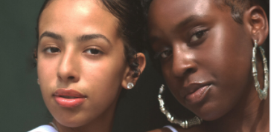
Stop Hate and Bias Against Asian Communities  (5/12 Webinar)  SmartHealth link | May 3, 2021 through  May 12, 2021 |  | Washington Immigrant Network (WIN)  Joanne Lee
RAIN Spotlight: Celebrate Pride Month | June 1, 2021 -  June 30, 2021 | 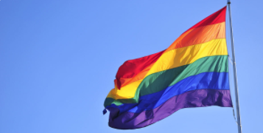 | Rainbow Alliance and Inclusion Network (RAIN)  Ryan Douglas
Celebrate Juneteenth | June 7, 2021 –  June 20, 2021 | TBD – Image of Juneteenth flag  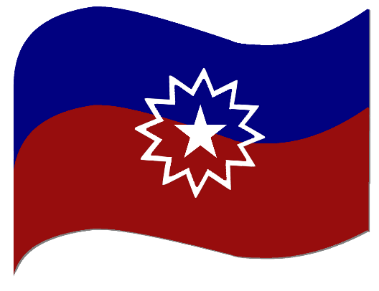 | Blacks United in Leadership and Diversity (BUILD)  Megan Matthews
TBD -  National Hispanic Heritage Month | September 15, 2021 -  October 15, 2021 | TBD | Latino Leadership Network  Indira Melgarejo Carvajal

