The following staff member has reviewed all critical elements of overdose prevention, recognition, response, and follow up care as outlined below with the client receiving prepackaged overdose reversal medication.
Topic | Staff Initials
Risk Factors for Overdose
Signs of Overdose
Overdose Response
Naloxone Administration
Good Samaritan Law
Withdrawal Symptoms
Risk for Recurrent Overdose

Client Name:

Client Label here
Client DOB:
Staff Name:
Date:

I, the client receiving naloxone, confirm my understanding of how to use naloxone and ways to reduce my risk of overdose.
Signature:
Date:

Client education video QR code:
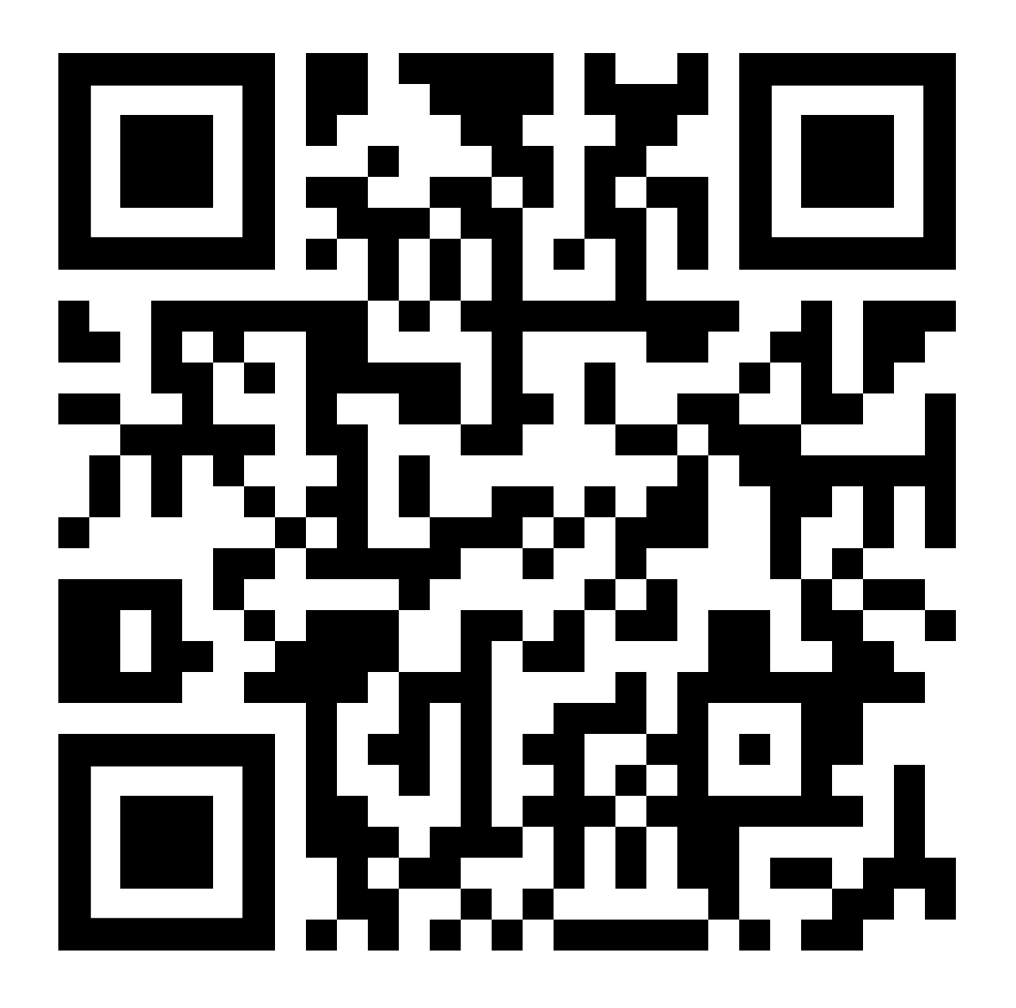
https://vimeo.com/357020563
Source: WA Department of Health- Opioid Overdose: Administering Naloxone Video

