Washington State Medicaid Transformation Project Demonstration

Section 1115 Waiver Quarterly Health IT Operational Report

Demonstration Year 2: (January 1, 2018 to December 31, 2018)

Federal Fiscal Quarter: Second Quarter (April 1, 2018 to June 30, 2018)

**Demonstration Year 2 – Quarter 2**

**April 1, 2018 – June 30, 2018**

The Health IT Operational Plan is composed of actionable deliverables to advance the health IT goals and the vision articulated in the Health IT Strategic Roadmap (<https://www.hca.wa.gov/assets/program/health-information-technology-strategic-roadmap.pdf>) in support of Medicaid Transformation in Washington State. The focus of the Health IT Roadmap and Operational Plan aligns with the three phases of work in the Medicaid Transformation Initiative: design, implementation and operations and assessment. The Health IT Operational Plan includes 92 deliverables and tasks in multiple areas including: data, data analytics, data governance, health IT/health information exchange (including the training needs of Accountable Communities of Health (ACHs)), financing, master person identifier, provider directory, and evaluation. This year, 2018, is largely focused on identifying and advancing the data needed by the state, ACHs, and providers; technology tools needed by providers for interoperable health information exchange (HIE); and existing infrastructure projects (i.e., Clinical Data Repository (CDR).

# Success Stories

The Health IT team continued to engage with the ACHs to understand their Health IT capacity and develop targeted technical assistance to advance their regional projects and ensure Health IT and HIE elements are incorporated. During the second quarter, HCA hosted several health IT Operational Plan updates and technical assistance webinars for ACHs that connected foundational elements of health IT and HIE with ACH project plans.

HCA conducted individual meetings with ACHs to understand regional needs and differences and what support from HCA, DOH and federal partners would help advance the ACH’s Health IT and health information exchange goals for providers in their regions. As a result of these conversations, HCA expects that ACHs will leverage and expand providers’ use of the interoperable Health IT and HIE infrastructure available and emerging through the statewide health information exchange organization, OneHealthPort (OHP), including providers’ use of OHP’s health information exchange service and the CDR.

The second quarter of 2018 saw a continuation of the Substance Use Disorder (SUD) HIE and Consent Management Workgroup with multiple state agencies collaborating and sharing information to support the exchange, re-use and consent management of SUD information. HCA, in collaboration with DoH, submitted to CMS an application for an IMD Waiver (as an amendment to its Medicaid Transformation Program). The IMD Waiver includes a SUD Health IT Plan primarily focused on enhancing the functionality and use of the Prescription Monitoring Program.

HCA continues to implement its behavioral health data streamline project that will meet health IT interoperability goals. The agency has secured a project manager and is working to augment state staff with contracting staff to successfully implement the project.

HCA shared with ACHs information about Health Information Sharing Assessments. As requested, HCA assisted ACHs in designing assessments of providers’ HIE capacity. HCA provided a memo to an ACH on 90/10 funding. HCA leadership is reviewing two Biennium Budget Decision Packages (DPs) (for State Fiscal Years 2019 – 2021) requesting state funds to draw down enhanced federal Medicaid matching payments using MMIS and HITECH authorities. The DPs identify several areas for which enhancements to support statewide HIE are needed. Once approved by HCA, the packages will be advanced for consideration by the Governor, and if approved, advanced to the state legislature for authorization.

An Implementation Advance Planning Document (IAPD) was approved by CMS on 4/25/18. The IAPD requested funds (using enhanced federal match rates) for FFY 2018 and FFY 2019. Some of the activities included in the approved IAPD include:

* Design, Development and Implementation (DDI) costs for the Medicaid EHR Incentive Payment Program and planning.
* Support implementation activities for meaningful use initiatives in the State Medicaid Health Information Technology Plan.
* Expand data in the CDR.
* Subsidize/reduce CDR on-boarding costs.
* Acquire data exchange tool(s) to provide access to data from non-EHR systems used by behavioral health (both mental health and substance abuse) and long-term care providers; and cleanse, transform and load into the CDR. Work is underway to integrate into the CDR pharmacy data from state-operated residential service providers for persons with developmental disabilities.
* Continue support for DOH use of the HIE and build on the interoperability between DOH surveillance systems and registries and Medicaid provider EHR systems to increase Meaningful Use so that critical population health and surveillance data is reported and accessed from the point of care.
* Continue support for Project Management Resource to support the Health IT Operational Plan initiatives.

# Progress to date

Washington State has made considerable progress in advancing its Health IT Operational Plan, including coordinating with Tribes; disseminating information to ACHs and partners on state and national health information exchange resources; introducing ACHs, providers and others to the CMS Health Information Sharing (HIS) assessment and supporting ACHs in their efforts to assess the health IT/HIE capacities and needs of providers in their region; and continuing the SUD HIE and Consent Management Workgroup.

At the end of Q2, HCA completed approximately 95% of all deliverables due in Quarter 2. There was one deliverable that remain overdue (discussed further in the challenges section of this report).



Washington State continues to work on deliverables in all major deliverable categories.



# Challenges

While substantial progress has been made there is a one deliverable that is overdue. This deliverable include the following:

|  |  |  |
| --- | --- | --- |
| **Task Number** | **Task** | **Comment** |
| **O5-011** | Based on assessment findings and need (and barriers/ gaps) for HIE at the point of care, and available HIT/health information exchange tools. HCA will identify:  •  shared HIT/health information exchange/care coordination tools  •  funding for shared HIT/health information exchange tools  • shared HIT/health information exchange contracts/contracting language | Task updated and edits:   * HCA engaged in one on one conversations with ACHs through which shared/common HIE needs were identified across ACHs. * HCA is developing a 24 month HIE/CDR Roadmap that includes several activities that are topically aligned with ACH identified needs. * CMS approved an amendment to the Medicaid Transformation Project to permit Medicaid coverage of substance use disorder (SUD) services in Institutions for Mental Diseases (IMDs). The IMD Waiver requires an SUD HIT Plan which includes tasks related to enhancing the functionality and use of the Prescription Monitoring Program, and supporting the exchange and consent management of SUD information.  HCA will pursue funding to support the implementation of these activities. * HCA continues conversations with OneHealthPort (OHP) to determine the feasibility of supporting priority HIE areas and considering additional resources, if necessary. * As described above, HCA staff developed two DPs requesting state funds to support health information exchange at the point of care using statewide HIE solutions. * In Q3 and Q4, the CY ’19 HIT Operational Plan will be drafted to include key infrastructure activities that will be undertaken to support and expand statewide HIE; and will include tasks to support the SUD HIT Plan (in the recently approved IMD Waiver), and other activities needed to support the MTP. |

# Changes in Health IT Operational Plan

There were no changes to deliverables during the 2nd quarter of 2018

# Clinical Data Repository Monthly Report

Per CMS request, attached to this quarterly report is the most recent monthly CDR status report.

# Next Steps

The State has initiated planning for the 2019 Health IT Operational Plan. This includes submitting decision packages for Health IT related items for consideration by agency leadership and governor’s staff for inclusion in the 2020 Governors Budget. This planning will be ongoing with an anticipated completion date of December 1, 2018 pending funding decisions.

Number of providers submitting to PROD:

* Total Org Parent : 52
* Total Org Child: 22

Please note that the above counts include stand alone parent and child orgs as well as linked parent & child orgs. Some providers are reported at the overall parent organization level and some at the child level (by specific facility/location).

Top 20 Organizations by total successful CCD submissions in July

1. University of Washington (110,583)

2. MultiCare Facilities (69,804)

3. PHS Washington Montana (69,733)

4. Swedish Medical Center (45,101)

5. Health Point CHC (40,507)

6. Franciscan Health System (30,272)

7. Neighborcare Health (29,449)

8. Confluence Health (23,835)

9. Kadlec Regional Medical Center (22,821)

10. Yakima Neighborhood Health Services (17,346)

11. Community Health Care (14,177)

12. Valley Medical Center Renton (7,504)

13. Country Doctor (6,194)

14. The Everett Clinic (5,262)

15. Tri-Cities Community Health (5,110)

16. Family Health Centers (5,099)

17. Pacific Medical Center (4,838)

18. Valley View Health Center (4,687)

19. Moses Lake Community Health Center (4,423)

20. Legacy Salmon Creek (3,993)

Number of Provider Organizations in UAT in last month: 19

Current time-based extension requests: 64 (final count, no longer accepting extension requests)

CDR Tickets at HCA: 10 and CDR Tickets at OHP: 9

Please see enclosed maps for further detail:

* Green set of maps: percentage of clients with at least one CCD in their record (by county & by ACH)
* Brown set of maps: percentage of clients with at least one claim in their record (by county & by ACH)
* Blue set of maps: distribution of Medicaid clients across the state (by county & by ACH)

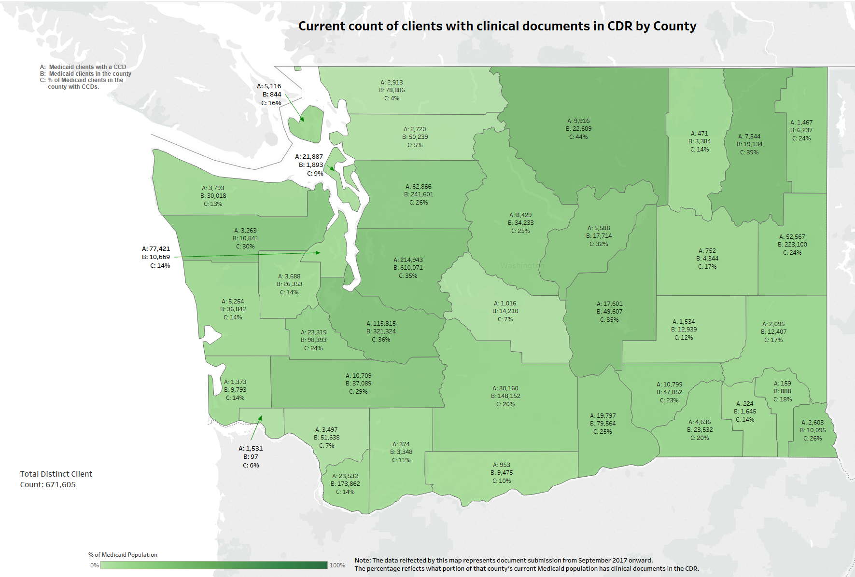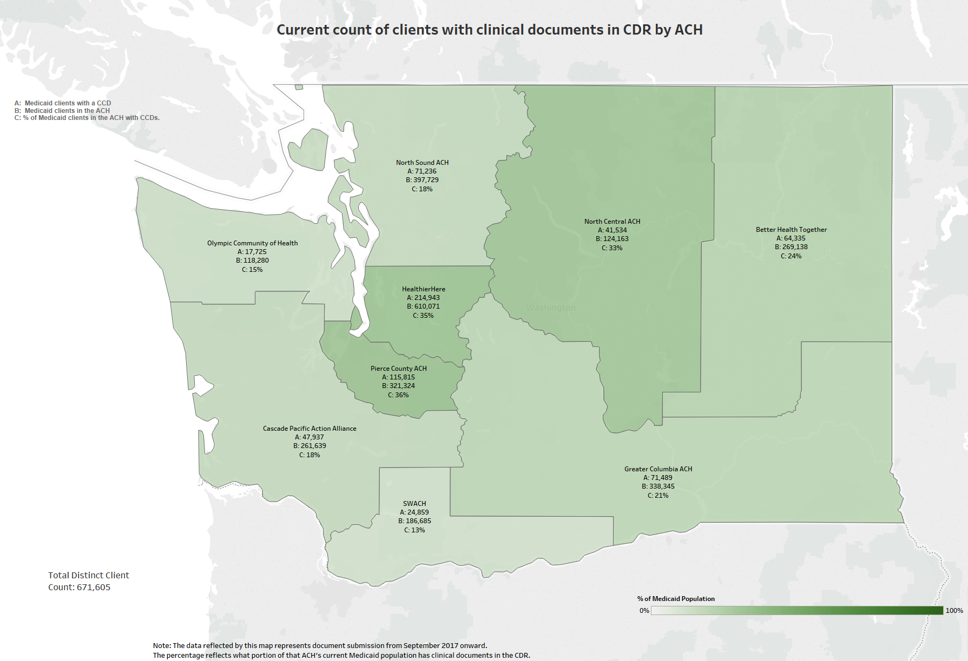

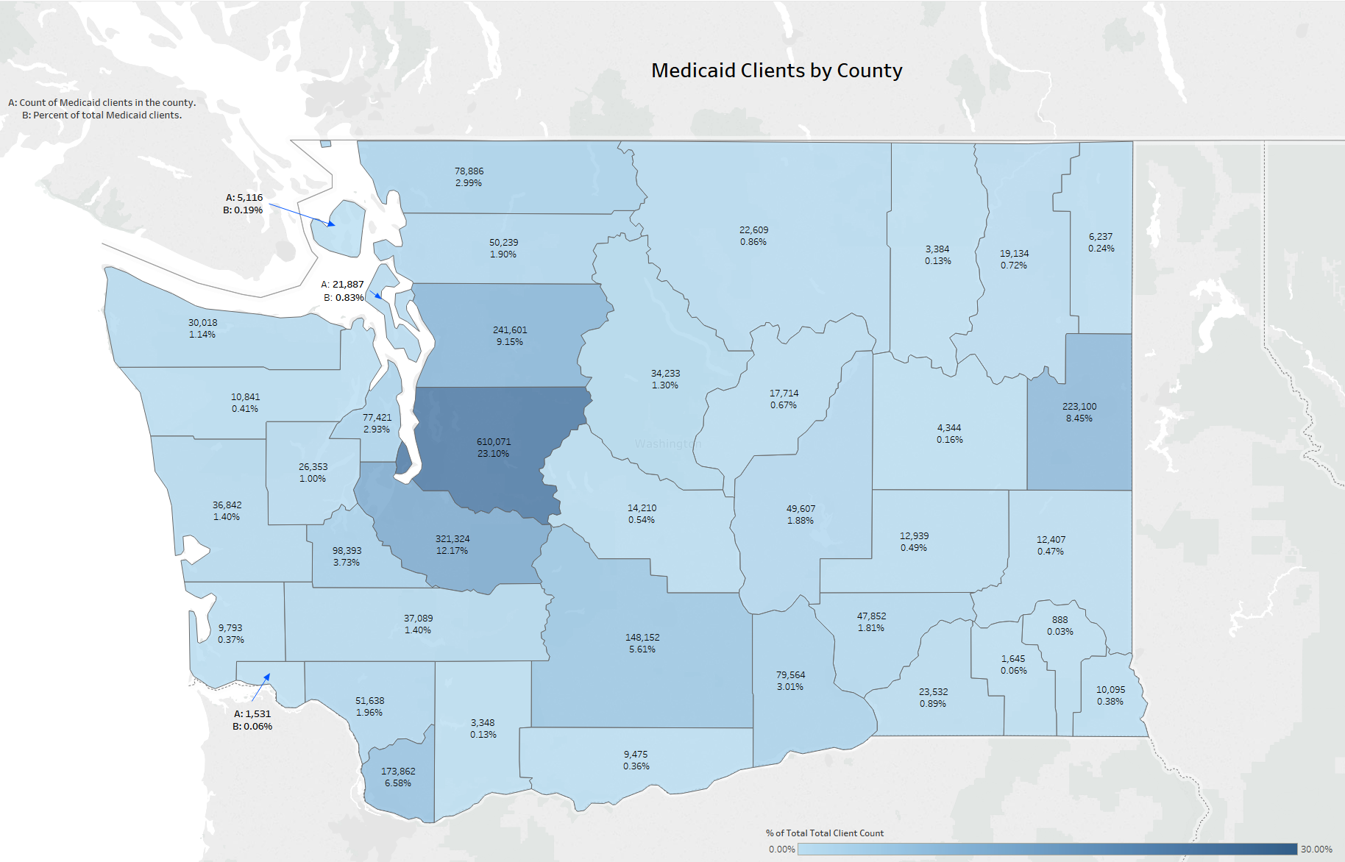

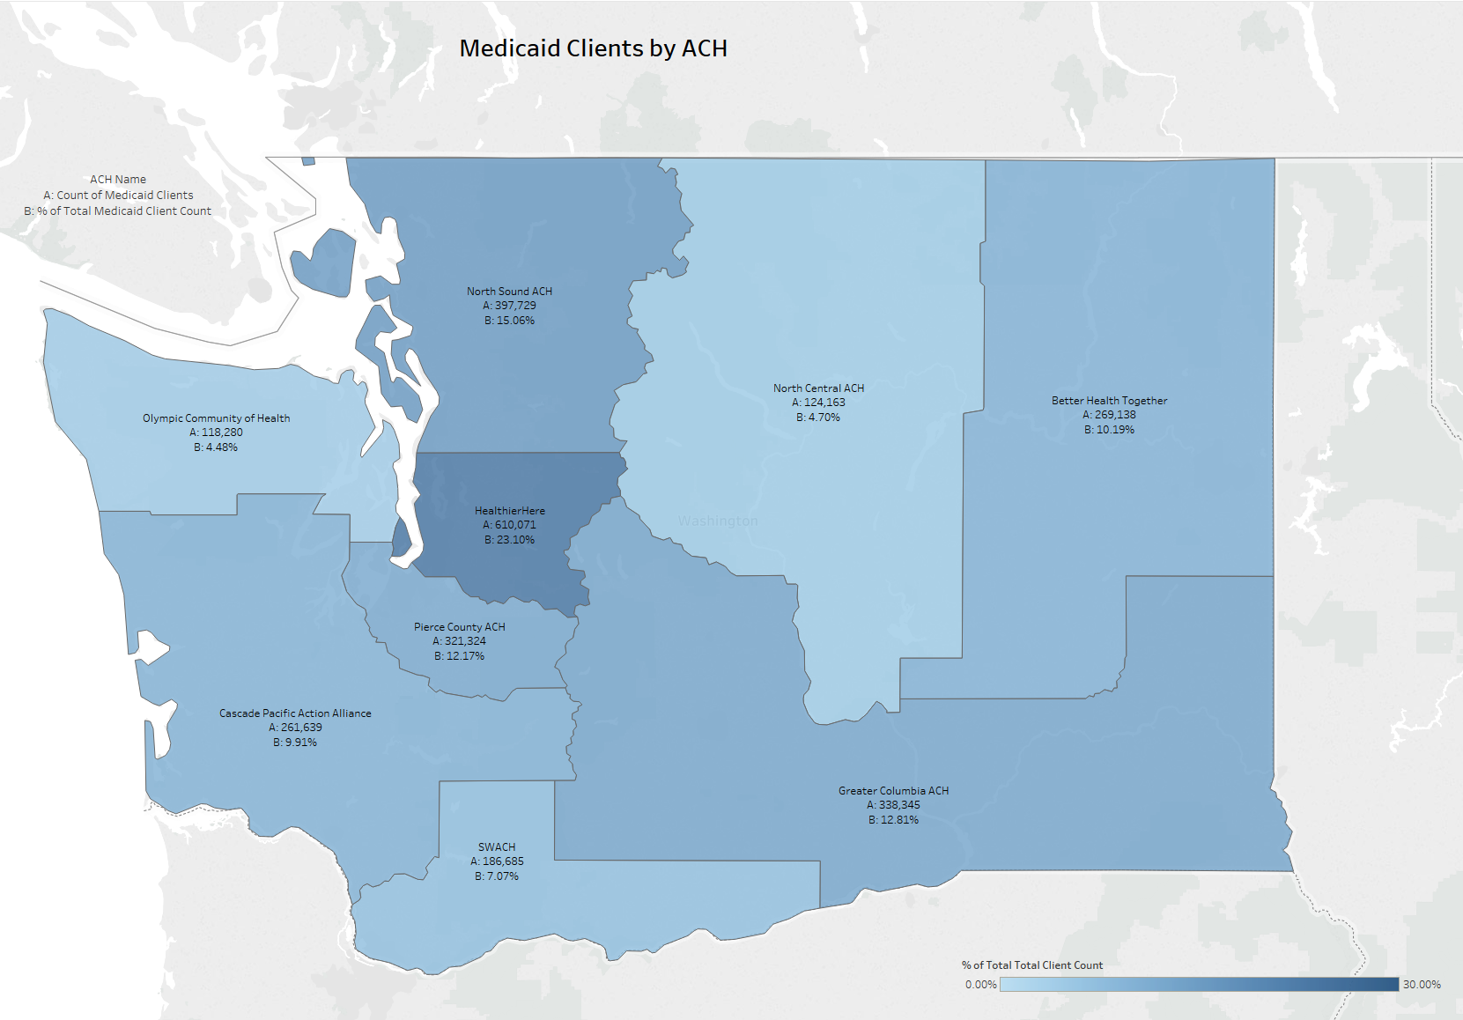

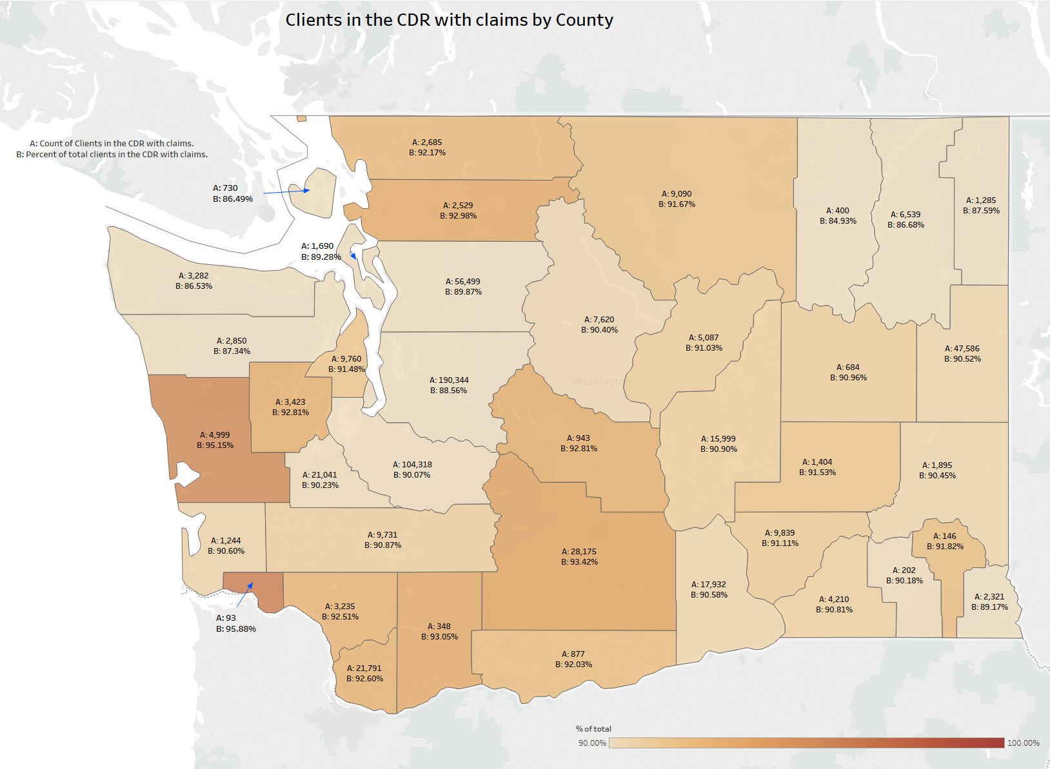

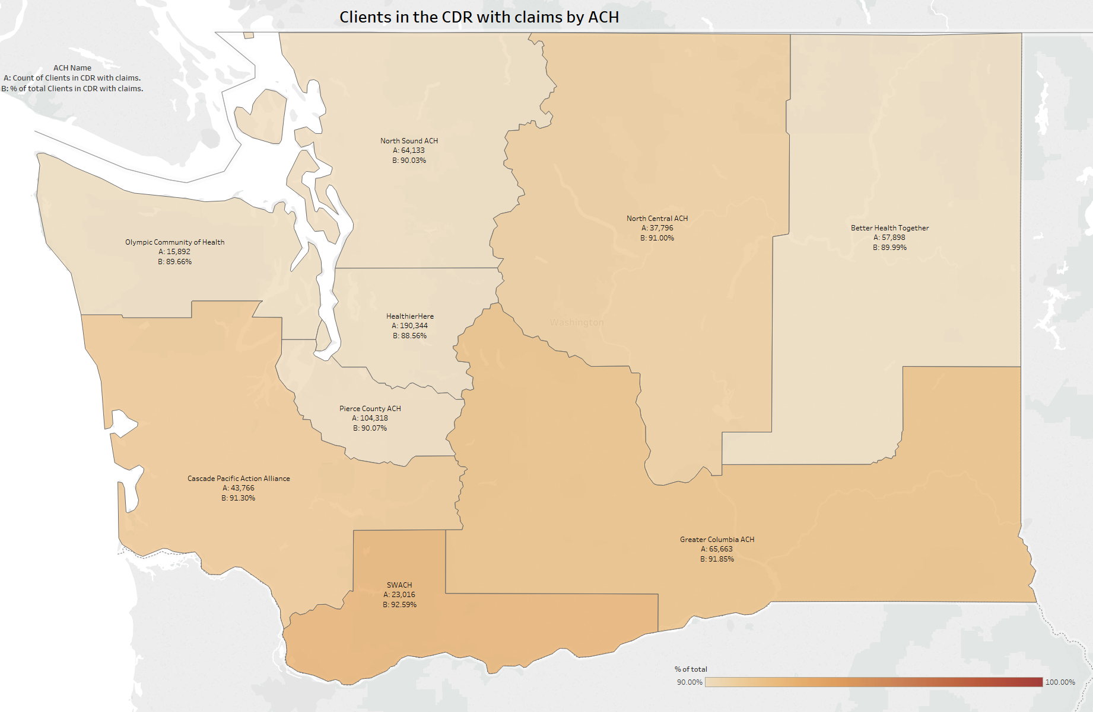

| **Init.** | **% Complete** | **Start** | **End** | **Deliverable Description** | **Qtr** | **Status** | **Category** |
| --- | --- | --- | --- | --- | --- | --- | --- |
| 01-001 | 55.00 | 2/1/18 | 12/31/18 | HIT Operational Plan monthly meetings | Q4 | In Process | Monthly Meetings |
| 02-002 | 54.00 | 10/1/17 | 12/31/18 | Create a list of data sources needed for project implementation | Q4 | In Process | Data |
| 02-003 | 0.00 | 10/1/17 | 12/31/18 | Ensure data inventory will include comprehensive data list | Q4 | In Process | Data |
| 02-004 | 31.00 | 1/1/18 | 7/31/18 | Propose recommended policies, governance and infrastructure changes | Q2 | In Process | Data |
| 02-005 | 100.00 | 4/1/18 | 12/31/18 | HCA will review P1 project artifacts related to whether HCBS providers are HIPAA covered entities | Q4 | Complete | Data |
| 02-006 | 33.00 | 4/1/18 | 12/31/18 | SAMSHA-HCA will identify and streamline BH reporting requirements | Q4 | In Process | Data |
| 02-008 | 36.00 | 10/1/17 | 9/30/18 | Develop patient/provider attribution approach | Q4 | In Process | Data |
| 03-001 | 33.00 | 10/1/17 | 9/30/18 | HCA will define data aggregation and present options | Q3 | In Process | Data Governance |
| 03-002 | 0.00 | 4/1/18 | 12/31/18 | HCA will support and monitor progress of APCD | Q4 | In Process | Data Governance |
| 03-003 | 0.00 | 4/1/18 | 12/31/18 | HCA will invest in data aggregation in support of payment model 4 | Q4 | In Process | Data Governance |
| 03-004 | 0.00 | 1/1/18 | 12/31/18 | HCA will support Master Data management | Q3 | In Process | Data Governance |
| 03-005 | 0.00 | 1/1/18 | 12/31/18 | HCA will support Truven/IBM data model-phase 2 | Q3 | In Process | Data Governance |
| 03-006 | 100.00 | 8/1/17 | 3/31/18 | Payment Model 2 analytic support from AIM/RDA | Q4 | Complete | Data Governance |
| 03-007 | 100.00 | 4/1/18 | 4/1/18 | HCA will explore Provider One updates to support FQHC/RHC APM4 | Q4 | Complete | Data Governance |
| 03-008 | 88.00 | 1/1/18 | 12/31/18 | HCA will develop and disseminate data governance guidelines | Q4 | In Process | Data Governance |
| 03-009 | 0.00 | 1/1/18 | 12/31/18 | HCA will support ACHs in adhering to HCA data governance guidelines | Q4 | In Process | Data Governance |
| 03-010 | 100.00 | 10/1/17 | 3/31/18 | HCA and DSHS will consult with SAMHSA on 42 CFR Part 2 | Q1 | Complete | Data Governance |
| 03-011 | 100.00 | 10/1/17 | 3/31/18 | HCA will collaborate with ONC on state collaborative for SUD and other sensitive information | Q2 | Complete | Data Governance |
| 03-012 | 100.00 | 1/1/18 | 6/30/18 | HCA will encourage other state agencies to participate in ONC state learning collaborative | Q4 | Complete | Data Governance |
| 03-013 | 50.00 | 1/1/18 | 9/30/18 | HCA will share information about consent management of sensitive/SUD information | Q4 | In Process | Data Governance |
| 03-014 | 0.00 | 7/1/18 | 9/30/18 | HCA will identify components to pilot the exchange of consent management for 42 CFR part 2 | Q1 | In Process | Data Governance |
| 03-015 | 0.00 | 1/1/18 | 9/30/18 | Develop DSAs that adhere to state and agency policies for data governance | Q1 | In Process | Data Governance |
| 03-016 | 100.00 | 4/1/18 | 6/30/18 | Consult with ONC to understand 21st century cures act | Q2 | Complete | Data Governance |
| 03-017 | 0.00 | 4/1/18 | 12/31/18 | Statewide DSA strategy Complete | Q3 | In Process | Data Governance |
| 03-019 | 0.00 | 7/1/18 | 9/30/18 | HCA will encourage ACHs to partner with jails and corrections to ease burdens at transition | Q3 | In Process | Data Governance |
| 04-001 | 45.00 | 11/1/17 | 12/31/18 | HCA will build out dashboards for Medicaid standard reporting | Q3 | In Process | Data Analytics |
| 04-002 | 100.00 | 10/1/17 | 3/31/18 | HCA will create analytic ready data products | Q2 | Complete | Data Analytics |
| 05-001 | 50.00 | 10/1/17 | 12/31/18 | HIT/HIE Assessment strategy complete | Q4 | In Process | HIT/Health Information Exchange |
| 05-002 | 75.00 | 10/1/17 | 7/31/18 | Determine scope and results of HIT/HIE assessments of providers in ACHs | Q3 | In Process | HIT/Health Information Exchange |
| 05-003 | 100.00 | 1/1/18 | 3/31/18 | Introduce ACHs, Providers and other to CMS Health information sharing assessment | Q4 | Complete | HIT/Health Information Exchange |
| 05-004 | 25.00 | 1/1/18 | 9/30/18 | If needed, HCA will support ACHs in assessing provider HIT capacity | Q1 | In Process | HIT/Health Information Exchange |
| 05-005 | 89.00 | 1/1/18 | 7/31/18 | Explore HIT/HIE solutions to address barriers/gaps in ACH projects | Q4 | In Process | HIT/Health Information Exchange |
| 05-006 | 100.00 | 1/1/18 | 3/31/18 | Participate in round table discussions with tribal governments | Q3 | Complete | HIT/Health Information Exchange |
| 05-007 | 100.00 | 1/1/18 | 6/30/18 | Provide a presentation on HIE to tribal government leaders | Q1 | Complete | HIT/Health Information Exchange |
| 05-008 | 100.00 | 10/1/17 | 3/15/18 | HCA will consult with Tribal Government leaders to understand concerns related to privacy issues and identify solutions to address concerns | Q3 | Complete | HIT/Health Information Exchange |
| 05-009 | 100.00 | 10/1/17 | 12/31/17 | Tribes and IHCP will submit a IHCP planning funds plan for statewide improvement in AI/AN behavioral health | Q3 | Complete | HIT/Health Information Exchange |
| 05-010 | 0.00 | 1/1/18 | 9/30/18 | HCA and Tribal governments will consult and collaborate on HIE and PHM activities | Q1 | In Process | HIT/Health Information Exchange |
| 05-011 | 50.00 | 1/1/18 | 6/30/18 | HCA and ACHs will identify shared HIT/HIE care coordination tools, funding for HIE tools, and shared contracts/contracting language | Q2 | Overdue | HIT/Health Information Exchange |
| 05-012 | 100.00 | 4/1/18 | 9/30/18 | HCA will pursue 10% matching funding to support HIT/HIE assessment activities | Q1 | Complete | HIT/Health Information Exchange |
| 05-013 | 100.00 | 1/1/18 | 3/31/18 | HCA will explore CRM tool for ACHs | Q3 | Complete | HIT/Health Information Exchange |
| 05-015 | 0.00 | 4/1/18 | 12/31/18 | HCA will design and disseminate a quarterly report by provider and MCO that shows progress in who is using the CDR | Q3 | In Process | HIT/Health Information Exchange |
| 05-016 | 25.00 | 10/1/17 | 12/31/18 | HCA will convene a clinical group to provide guidance/feedback on the type and format of info in CDR | Q2 | In Process | HIT/Health Information Exchange |
| 05-017 | 75.00 | 10/1/17 | 12/31/18 | FHCQ will lead effort to create "high priority" use cases for CDR | Q3 | In Process | HIT/Health Information Exchange |
| 05-018 | 0.00 | 4/1/18 | 9/30/18 | HCA will convene group to prioritize CDR needs to meet the Medicaid transformation | Q1 | In Process | HIT/Health Information Exchange |
| 05-019 | 0.00 | 1/1/18 | 9/30/18 | HCA and OHP will develop a catalog of OHP services, provider types registered, and future services | Q4 | In Process | HIT/Health Information Exchange |
| 05-020 | 0.00 | 1/1/18 | 9/30/18 | HCA will work with OHP to identify EHR tools that do not support ProviderOne IDs | Q4 | In Process | HIT/Health Information Exchange |
| 05-021 | 0.00 | 1/1/18 | 7/31/18 | HCA will work with OHP to launch CDR provider portal | Q4 | In Process | HIT/Health Information Exchange |
| 05-022 | 0.00 | 10/1/18 | 12/31/18 | HCA will consider the need to provide individual level access to health information | Q3 | No Status | HIT/Health Information Exchange |
| 05-023 | 55.00 | 2/1/18 | 12/31/18 | Monthly TA meetings | Q3 | In Process | HIT/Health Information Exchange |
| 05-024 | 100.00 | 1/1/18 | 6/30/18 | Identify TA topics | Q3 | Complete | HIT/Health Information Exchange |
| 05-025 | 100.00 | 1/1/18 | 6/30/18 | Determine TA activities by QUALIS | Q3 | Complete | HIT/Health Information Exchange |
| 05-026 | 100.00 | 7/1/18 | 9/30/18 | HCA will consider needs to implement alternative TA and training support models to assist providers | Q4 | Complete | HIT/Health Information Exchange |
| 05-027 | 0.00 | 7/1/18 | 9/30/18 | HCA and ACHs will explore engaging private philanthropic organizations | Q4 | In Process | HIT/Health Information Exchange |
| 05-028 | 0.00 | 7/1/18 | 12/31/18 | HCA annual HIT/HIE roadshow | Q2 | In Process | HIT/Health Information Exchange |
| 05-029 | 0.00 | 7/1/18 | 9/30/18 | Contract for white paper describing best security practices for HIT/HIE | Q2 | In Process | HIT/Health Information Exchange |
| 05-030 | 0.00 | 4/1/18 | 9/30/18 | Disseminate security practices white paper | Q3 | In Process | HIT/Health Information Exchange |
| 05-031 | 0.00 | 4/1/18 | 9/30/18 | Identify performance measures related to adoption of HIT/HIE | Q3 | In Process | HIT/Health Information Exchange |
| 05-032 | 0.00 | 7/1/18 | 9/30/18 | Share HIT/HIE performance measures with independent evaluator | Q4 | In Process | HIT/Health Information Exchange |
| 05-033 | 0.00 | 7/1/18 | 9/30/18 | Disseminate performance measures | Q3 | In Process | HIT/Health Information Exchange |
| 05-034 | 0.00 | 4/1/18 | 9/30/18 | HCA will explore methods with MCOs to encourage provider use of HIE technologies | Q3 | In Process | HIT/Health Information Exchange |
| 05-035 | 100.00 | 10/1/17 | 12/31/18 | HCA will compile and disseminate contact list | Q3 | Complete | HIT/Health Information Exchange |
| 05-036 | 50.00 | 2/3/18 | 12/31/18 | ONC quarterly updates | Q3 | In Process | HIT/Health Information Exchange |
| 05-037 | 8.00 | 10/1/17 | 12/31/18 | Reporting to Federal Government | Q3 | In Process | HIT/Health Information Exchange |
| 06-001 | 100.00 | 4/1/18 | 6/30/18 | HCA will identify 90/10 funding sources | Q3 | Complete | Financing |
| 06-002 | 13.00 | 10/1/17 | 12/31/18 | HCA will pursue funding sources to meet HIT needs | Q4 | In Process | Financing |
| 06-002 | 100.00 | 4/1/18 | 6/30/18 | HCA will seek federal guidance on 10% match | Q4 | Complete | Financing |
| 06-003 | 0.00 | 1/1/18 | 12/31/18 | HCA will actively explore opportunities to leverage 90/10 match | Q4 | In Process | Financing |
| 06-004 | 0.00 | 4/1/18 | 12/31/18 | If needed identify a leg. Strategy | Q2 | In Process | Financing |
| 06-005 | 0.00 | 4/1/18 | 12/31/18 | identify opportunities for shared HIT financial investments | Q4 | In Process | Financing |
| 06-006 | 0.00 | 1/1/18 | 12/31/18 | HCA will support identified funding requests | Q2 | In Process | Financing |
| 06-007 | 0.00 | 1/1/18 | 6/30/18 | HCA will procure Fraud Abuse Detection System tools for EDW | Q4 | In Process | Financing |
| 07-001 | 0.00 | 1/1/18 | 6/30/18 | HCA will discuss options and authority to advance Master patient identifier | Q4 | In Process | Master Person Identifier |
| 07-002 | 0.00 | 10/1/18 | 12/31/18 | If appropriate, HCA will pursue 90/10 funding to implement master patient identifier | Q4 | No Status | Master Person Identifier |
| 08-001 | 62.00 | 10/1/17 | 12/31/18 | Determine feasibility of using 90/10 funding for provider directory tasks | Q4 | In Process | Provider Directory |
| 08-002 | 0.00 | 10/1/17 | 7/31/18 | Consider enhancements to current provider license interface with ProviderOne | Q2 | In Process | Provider Directory |
| 08-003 | 43.00 | 7/1/18 | 12/31/18 | HCA, will identify provider directory use cases | Q2 | In Process | Provider Directory |
| 08-003 | 100.00 | 7/1/18 | 12/31/18 | Master Data Management provider files from Truven have been created | Q4 | Complete | Provider Directory |
| 08-003 | 100.00 | 7/1/18 | 12/31/18 | Procured list of PCPs | Q4 | Complete | Provider Directory |
| 08-003 | 100.00 | 7/1/18 | 12/31/18 | Cat 1 Provider data files in Excel form are available to ACHs in box.com | Q3 | Complete | Provider Directory |
| 08-003 | 0.00 | 7/1/18 | 12/31/18 | Determine resources to complete the tasks | Q4 | In Process | Provider Directory |
| 08-003 | 0.00 | 7/1/18 | 12/31/18 | Developing understanding of what is available in the Master Data Management | Q4 | In Process | Provider Directory |
| 08-003 | 0.00 | 7/1/18 | 12/31/18 | Complete Dashboard using the provider data file for the ACHs | Q4 | In Process | Provider Directory |
| 08-003 | 0.00 | 7/1/18 | 12/31/18 | Communicate availability of the Cat 1 provider files | Q4 | In Process | Provider Directory |
| 09-001 | 0.00 | 7/1/18 | 12/31/18 | HCA will present to leadership approaches for displaying P4P measures and means to explore sub-populations | Q4 | In Process | Data Visualization |
| 09-002 | 0.00 | 10/1/18 | 12/31/18 | HCA (if appropriate) will determine costs of data visualization and identify funding sources | Q4 | No Status | Data Visualization |
| 10-001 | 83.00 | 2/1/18 | 12/31/18 | An independent evaluation of Health IT/HIE activities will be conducted in accordance with evaluation protocol | Q4 | In Process | Project Evaluation |
| 10-002 | 0.00 | 10/1/18 0:00 | 12/31/18 | Share independent evaluation results | Q4 | No Status | Project Evaluation |
| 10-002 | 0.00 | 10/1/18 | 12/31/18 | Share independent evaluation results | Q4 | No Status | Project Evaluation |