

EMAIL COPY
June “Global Employee Health and Fitness Month” Micro Campaign

Title/Subject line:10 minutes of exercise can make all the difference

Subtitle/Preheader: Learn about the diabetes prevention program powered by Omada®.

Body Copy:
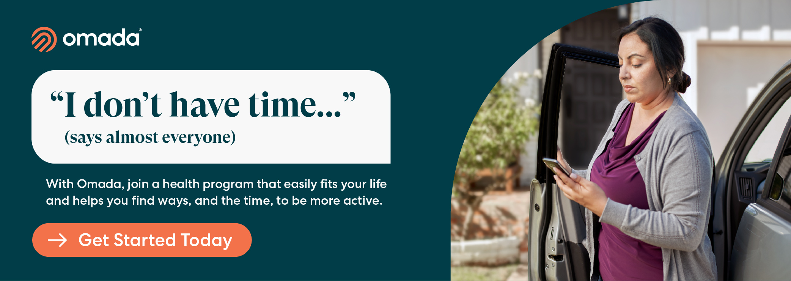

Being busy can make it so exercise is at the bottom of the “to do” list. But starting an exercise habit doesn’t take a lot of time. With just 10 minutes a day, you can improve your health.

The PEBB Program offers a diabetes prevention program (DPP) powered by Omada to support you:

- “I don’t have time…” Only 10 minutes a day can make a difference. On average,
members engage in their program 1-2 hours each week.
- “I don’t know where to start...” Your health coach has your back. They’ll point you
in the right direction with a wellness plan tailored to fit your life.
- “I don’t like the gym…” A gym can help but you can do a lot at home. The DPP
shows you how to add more physical activity into your daily routines.

Check if you’re eligible

If you or your adult family members are at risk for type 2 diabetes, your PEBB medical plan will cover the entire cost of the program.
The PEBB diabetes prevention program is powered by Omada. Omada also offers a diabetes management program for PEBB members enrolled in Uniform Medical Plan (UMP) plans. To learn more about these programs, visit Diabetes programs.

