We recommend sharing the banner ad (included below) and the below copy if you are looking to do an employee email or newsletter article.

EMAIL COPY - “YOU’VE GOT SUMMER”

Title/Subject Line: Who needs New Year’s when you’ve got summer?
Subtitle/Preheader: Improve your health and help prevent type 2 diabetes with healthy habits that fit your lifestyle

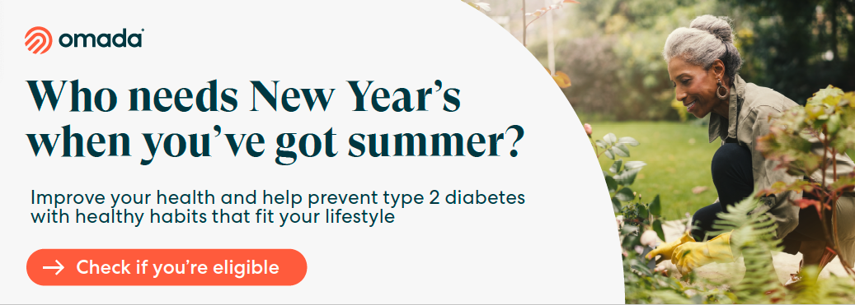

It’s never too late to take small steps to be more active, improve your health, and help prevent type 2 diabetes.

With the Diabetes Prevention Program powered by Omada, you have a virtual care program that gives you a personal health coach to guide and motivate you. Step into summer with a fresh start.

All in a day
This summer try these small, simple activities.

- Cool off in the shower. The colder your shower, the more work your body is doing to heat itself. Every goosebump is a tiny muscle in action.
- Move at your workstation. Make it a habit to stand up every 30 minutes to give your back, legs, and arms a good stretch.
- Add a few steps to each morning. Morning walks can help clear your mind, lift your mood, improve flexibility, and boost energy.
- Give your eyes and brain a screen break. Try 20 minutes a day with no screen time and start “seeing” the health benefits.
- Enjoy lunch outside. Let natural daylight and fresh air help boost your body’s level of vitamin D, lower stress, and improve mood. Plus, your lunch may taste better.
- Skip the couch or lounger during TV time. Sit on the floor. It opens up your hips and lets your knees work at different angles. Hard floor? Grab a pillow.

Check if you’re eligible

* If you or your adult family members are at risk for type 2 diabetes, your PEBB medical plan will cover the entire cost of the program.

The PEBB Diabetes Prevention Program is powered by Omada. Visit Diabetes prevention to learn more.​

