

EMAIL COPY
BENEFITS EDUCATION 2025

The copy below is useful for employee emails, employee newsletters, and other company channels. The copy is also useful if introducing and supplementing the flyer and/or banner.
—--------------------------------------------------------------------------------------------------------------------------

Title/Subject Line: Get support with a diabetes management program

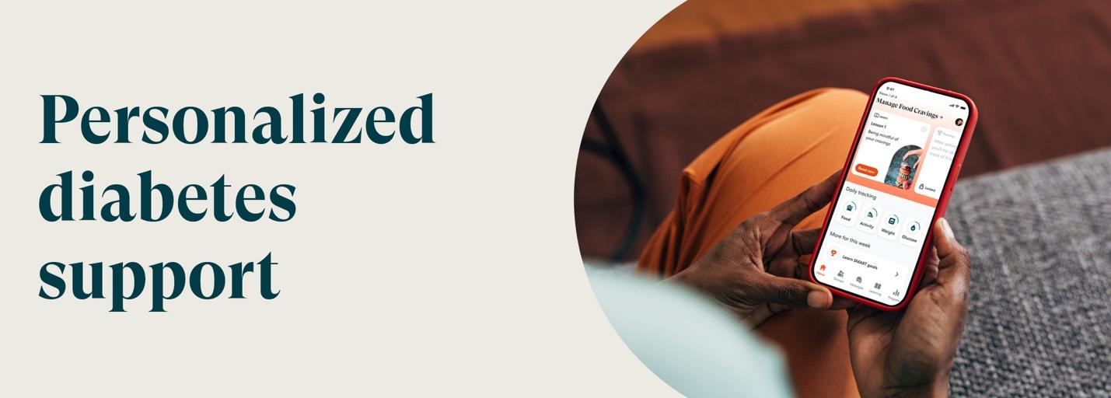

The PEBB Program offers an easy-to-follow diabetes management program (DMP) powered by Omada®. The DMP can help you make realistic, long-term changes to your health and well-being.

You’ll receive the support of a personal health coach to guide you on your wellness journey. Gain confidence without the stress of trying to get healthy on your own.

Check to see if you’re eligible

The DMP is an easy-to-follow personalized program

- Test strips and lancets included
No need to reorder supplies. They’re automatically shipped based on usage.

- Focus on progress, not perfection
Build healthy habits for long-term success, not quick fixes.

- Personal support without judgment
A health coach will help tailor the program to fit your needs—with positive encouragement to help you stay on track.

Get Started

You’ll receive a welcome kit*
It contains easy-to-use smart devices based on your needs that is shipped to your door and yours to keep.

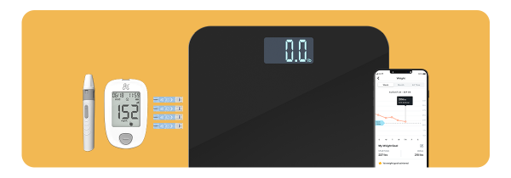

- Blood glucose meter (BGM)
- Ongoing supply of test strips and lancets
- Smart scale

You can also use BGMs they already love.

If you or your adult family members are living with diabetes and are enrolled in a Uniform Medical Plan (UMP) plan, your plan will cover the cost of the program. This may include a connected glucose meter with as many test strips as you need and a smart scale—all yours to keep. Call UMP Customer Service at 1-800-628-3481 (TRS: 711) for questions about the program eligibility requirements.

The PEBB diabetes management program powered by Omada is available to PEBB UMP members. To learn about the diabetes management programs for Premera and Kaiser members, see Diabetes programs.

