We recommend sharing the banner ad (included below) and the below copy if you are looking to do an employee email or newsletter article.

EMAIL COPY - “TRAVEL HEALTHY”

Title/Subject Line: Travel healthy this summer
Subtitle/Preheader: Take the Diabetes Prevention Program powered by Omada with you wherever you go

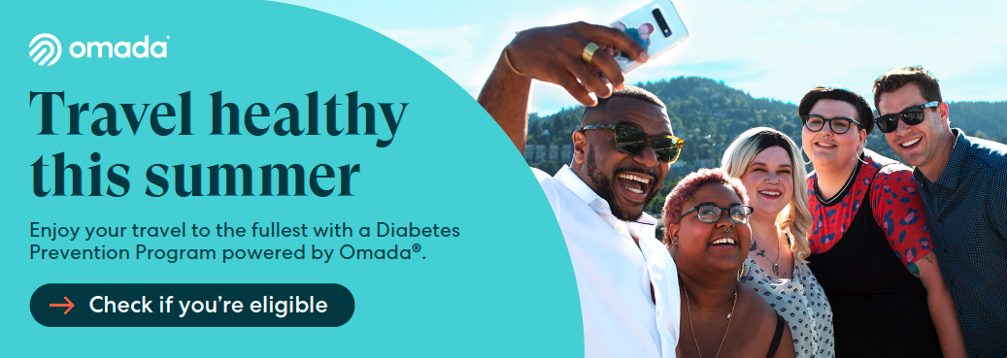

Summer is a time when many people are excited to break out of their routine and explore. But the excitement of travel can lead to stress, especially if trying to stay on track with health goals and preventing type 2 diabetes.

With the Diabetes Prevention Program powered by Omada, you have a personal health coach at all times. Your coach can help you prepare for a trip and will stay in touch to help you enjoy your travels.

Food and activity choices can play a role in your risk of developing type 2 diabetes. Enjoy your travels to the fullest with some helpful tips:

- Pre-plan snacks. Pack a bag of healthy snacks every time you head out. This can help curb cravings, boost energy, and save you money.
- Drink plenty of water. Bring a reusable water bottle with you. Refill it when you can to stay hydrated, avoid fatigue, and get better sleep.
- Set goals to stay active. Take 10 minutes a day to move your body. Swim in the hotel pool, go for a short walk, or use the stairs instead of the elevator.

“[Omada] truly guided how I ate, prepped me for the active days, and I still enjoyed myself.” — Omada member

Check if you’re eligible

If you or your adult family members are at risk for type 2 diabetes, your SEBB medical plan will cover the entire cost of the program.

The SEBB Diabetes Prevention Program powered by Omada is available to SEBB members enrolled in Kaiser Permanente or UMP plans. Premera Blue Cross members have a different program available. Visit Diabetes programs to learn more.

