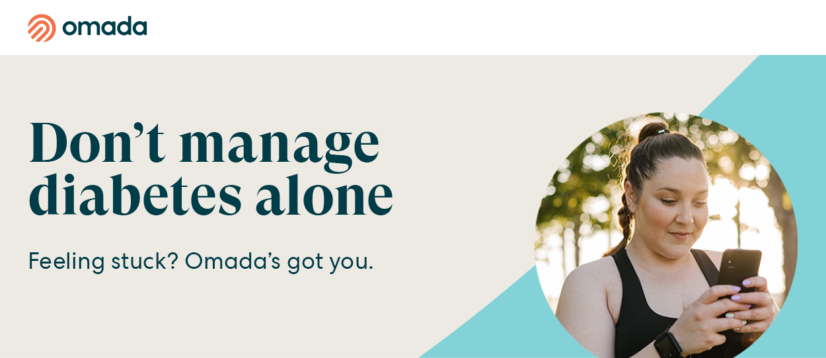

Omada’s diabetes management program gives you a personal health coach and clinical specialist who are there every step of the way to help you take control of diabetes — so you can live your healthiest.

Omada helps you build confidence for better health with our diabetes management program:
- A partner in health: Your health coach helps you make easy lifestyle tweaks so you can get your blood sugar under control.

- Your clinical expert: Your specialist helps monitor your blood glucose. If it's too high or low they'll provide guidance to help you correct it.

- A plan created just for you: Your coach helps you build a plan to improve your overall health, tailored to your lifestyle and culture.
- Results you've dreamed about: You are 5x more likely to achieve your health goals with the support of your care team.*

Check if you’re eligible.
The SEBB diabetes management program powered by Omada is available to SEBB UMP members. To learn about the diabetes management programs for Premera and Kaiser members, see Diabetes programs.

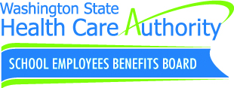
Disclaimers

Omada program does not replace advice and guidance received from their doctor/health care provider.

*Omada internal analysis, member population data 8/2020-3/2021, on our diabetes, prediabetes and hypertension programs.

App images are fictionalized samples and do not reflect information about a specific person.

Subject Line: Live with diabetes? Ready for a change? Join Omada today.

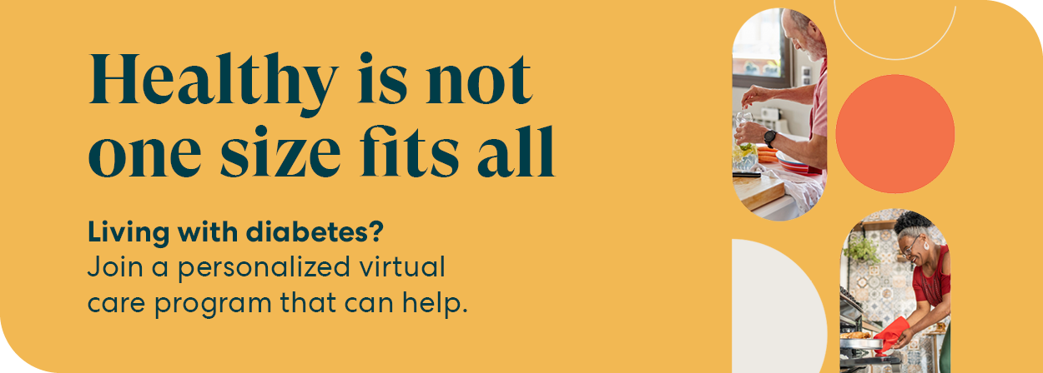

Living with diabetes can be stressful. Omada gives you a personal health coach and clinical specialist to help you balance your care with the rest of your life, so you can live to the fullest.

With Omada, you'll get:
- One-on-one support from a personal health coach
- Easy monitoring with glucose monitors, test strips and smart scale
- Clinical guidance from a certified diabetes specialist
- Tools for managing stress to ensure your mindset is healthy, too

Omada can help you:

- Manage diabetes more easily
- Through guidance from your health coach and certified diabetes specialist
- Blood glucose meter and ongoing supply of test strips and lancets
- Maintain a healthy body
- With one-on-one health coaching
- A smart scale to monitor progress*
- Nutrition tips, ideas, and recipes
- Improve your overall health
- With personalized feedback
- Interactive lessons
- Support for your mental health

Check if you’re eligible.
The SEBB diabetes management program powered by Omada is available to SEBB UMP members. To learn about the diabetes management programs for Premera and Kaiser members, see Diabetes programs.

Disclaimers

Omada program does not replace advice and guidance received from their doctor/health care provider.

*Omada cohort study on the diabetes program, 2022; average results after 12-month follow-up for members with A1C equal to or above 8% at baseline; Actual member outcomes may vary based on individual and demographic factors.

†Sarah is a fictionalized member and app images are fictionalized samples created to illustrate an Omada experience.

