**Omada logo**

**EMAIL COPY  
INTRODUCTION TO OMADA 2025**

The copy below is useful for employee emails, employee newsletters, and other company channels. The copy is also useful if introducing and supplementing the flyer and/or banner.

______________________________________________________________________

**Title/Subject Line:** **Elevate your health with our partner - Omada Health**



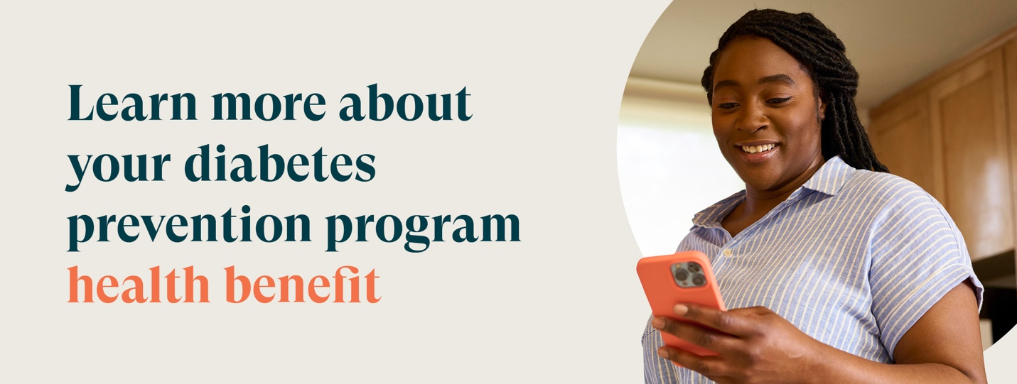

Your health is your most valuable asset, and as part of our commitment to your well-being, we are excited to offer a diabetes prevention program (DPP) powered by Omada®.

The DPP helps members create healthier habits that can help lower the risk of developing chronic conditions like diabetes.

Here's how DPP can help you in your health journey:

* **One-on-one support**: You’ll get paired with a personal health coach who provides guidance, encouragement, and support specific to your health goals.
* **Personalized approach**: Omada gives you access to tools and resources that meet your specific needs.
* **Effortless to start**: You get a welcome kit delivered to you at no extra cost.

Whether it’s, increasing energy levels or improving overall health, we encourage you to explore DPP’s—it's your opportunity to manage your health in a way that fits with your day-to-day life.

Your welcome kit will contain a smart scale that:

* Is easy to use
* Automatically syncs to the Omada app
* Ships to your door, yours to keep

[**Check to see if you’re eligible**](https://go.omadahealth.com/wasebb)

If you or your adult family members are at risk for type 2 diabetes, your SEBB medical plan will cover the entire cost of the program.

The SEBB Diabetes Prevention Program powered by Omada is available to SEBB members enrolled in Kaiser Permanente or UMP plans. Premera Blue Cross members have a different program available. Omada also offers a diabetes management program for SEBB members enrolled in UMP. To learn more about these programs, visit hca.wa.gov/sebb-diabetes.

**Disclaimers**

Actual participant outcomes may vary based on individual and demographic factors.