We recommend sharing the banner ad (included below) and the below copy if you are looking to do an employee email or newsletter article.

EMAIL COPY – It’s World Heart Day

Title/Subject Line: It’s World Heart Day
Subtitle/Preheader: The Diabetes Prevention Program powered by Omada is here to help prevent type 2 diabetes and heart disease.

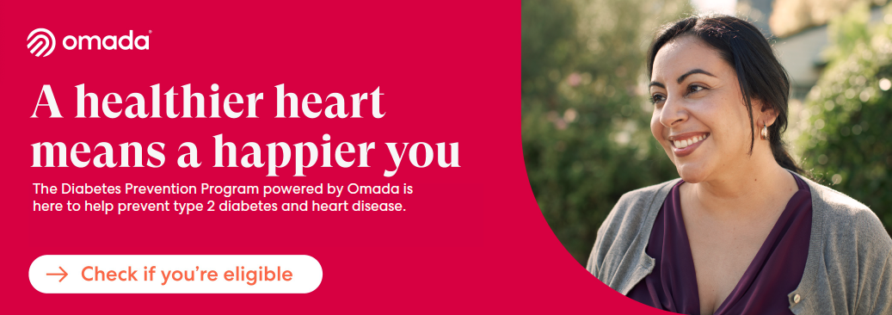

Join over 1 million people who’ve enrolled in the Diabetes Prevention Program powered by Omada. It’s a virtual care program designed to help build healthy habits, help prevent type 2 diabetes, and improve overall health. It can also help reduce the risk of heart disease, a leading cause of death in the U.S., according to the Centers for Disease Control and Prevention.
Get personalized diabetes prevention support from anywhere.
Help your heart through doable, daily changes that stick.
• Dedicated care team: One-on-one support from anywhere
• Flexible wellness plan: Personalized advice and lessons tailored to your lifestyle
• Tools for reducing stress: To ensure your mindset is healthy too

Check if you’re eligible

* If you or your adult family members are at risk for type 2 diabetes, your SEBB medical plan will cover the entire cost of the program.

The SEBB Diabetes Prevention Program powered by Omada is available to SEBB members enrolled in Kaiser Permanente or UMP plans. Premera Blue Cross members have a different program available. Visit Diabetes programs to learn more.

