Email #1

Subject: See real results with the Diabetes Management Program by Omada
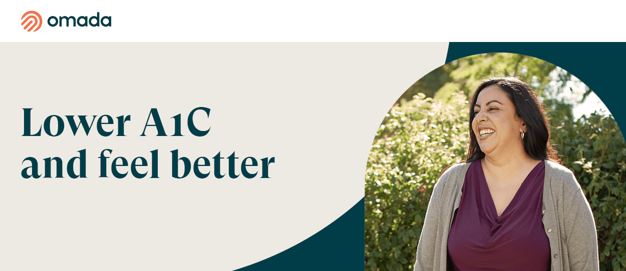

The Diabetes Management Program powered by Omada will help you improve your health and gain confidence through simple changes that fit into your everyday life. You’ll learn to eat better, improve sleep, and lower stress with tips and support from your own health coach and diabetes specialist.

You’ll also:

- Improve blood sugar levels
3 out of 4 Omada members met their A1C reduction goal in just a year.*
- Gain more energy
Learn what factors impact your energy and how to improve them.

You'll get support from your health coach and clinical specialist to:

- Rethink what you eat without cutting out your favorite meals or counting calories
- Learn what's stopping you from getting a good night's sleep
- Build healthy habits that will stick, for good
- Reduce stress with helpful tools to ensure your mindset is healthy, too

Check if you’re eligible.

The SEBB Diabetes Management Program powered by Omada is available to SEBB UMP members. To learn about the diabetes management programs for Premera and Kaiser members, see Diabetes programs.
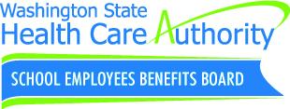
Disclaimers
*Omada internal analysis, member population data 8/2020 - 3/2021, on our diabetes, prediabetes, and hypertension programs.

Email #2

Subject: Get tools and support with the Diabetes Management Program by Omada

You have access to the virtual Diabetes Management Program powered by Omada as part of your benefits.

Get a welcome kit that includes a blood glucose meter to track glucose levels anytime and an ongoing supply of test strips and lancets. An Omada health coach and specialist will provide guidance on food choices, exercise goals, and medication tips based on glucose readings.
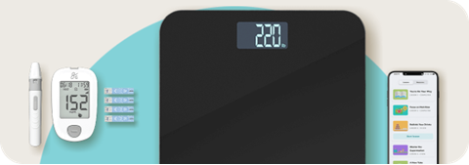

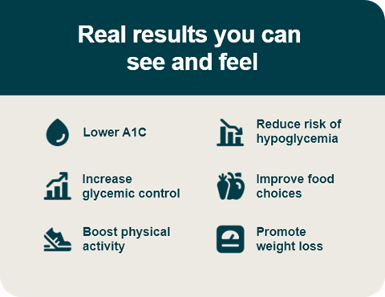

Check if you’re eligible.

The SEBB Diabetes Management Program powered by Omada is available to SEBB UMP members. To learn about the diabetes management programs for Premera and Kaiser members, see Diabetes programs.

Disclaimers
*Omada internal analysis, member population data 8/2020 - 3/2021, on our diabetes, prediabetes, and hypertension programs.

