Track Your Sleep Message (SEBB)

How to use
- Share the message below to promote the Track Your Sleep activity, which runs from April 6 to July 3, 2020.
- The message is ready to use as is or you can edit to make it work for your organization.
- If needed, finish by adding your contact information, logo, and more.

Tip: Highlight the value of worksite wellness by getting leadership to send the message. Doing this completes tasks 1.3 and 5.4 of our SmartHealth Worksite Wellness Roadmap to earn our Zo8 Award.

MESSAGE BELOW

Email Subject: Join the SmartHealth Track Your Sleep activity

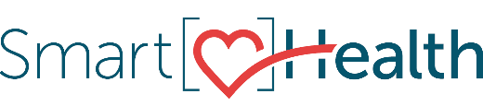
Join the SmartHealth Track Your Sleep activity today. Although you may need a little more or less, most experts agree that getting about seven hours of sleep each night is ideal.
Tracking your sleep habits, like when you go to bed and how often you wake up, is a great way to get to the root of sleep issues.

Have fun. Earn rewards.
The Roman poet Virgil said, “The greatest wealth is health.” In case you need another reason to join SmartHealth, you could also qualify for a $125 wellness incentive each year!

Share the news
Even if you waived SEBB medical benefits, you can use SmartHealth! Although you are not eligible to qualify for the $125, you can join in on the fun and support your journey toward living well. Learn more about SmartHealth for details.
Be well,

The SmartHealth Team
Supporting you on your journey toward living well

MESSAGE END

