Statewide Assessment Challenge Message (SEBB)

How to use
- Share the message below to promote the SmartHealth Statewide Assessment Challenge, which runs from January 3 to February 29, 2020.
- The message is ready to use as is or you can edit to make it work for your organization.
- If needed, finish by adding your contact information, logo, and more.

Tip: Highlight the value of worksite wellness by getting leadership to send the message. Doing this completes tasks 1.3 and 5.4 of our SmartHealth Worksite Wellness Roadmap to earn our annual Zo8 Award.
MESSAGE BELOW

Email Subject: Join the SmartHealth Statewide Assessment Challenge

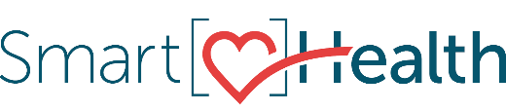

Help your organization rise to the top by joining the SmartHealth Statewide Assessment Challenge. SmartHealth is included in your new SEBB benefits and a voluntary wellness program that supports you on your journey toward living well.

Get started by completing your Well-Being Assessment (WBA). The WBA is foundational to SmartHealth and it gives you a complete picture of your physical, emotional, work/life balance, and financial well-being! This challenge ends February 29, so complete the WBA today and encourage your colleagues to do the same. There’s even a leaderboard to help your organization keep track as you rise to the top!

New to SmartHealth?
Watch the Why SmartHealth Matters video.

Have fun. Earn rewards.
Did you know that completing the WBA could help you qualify for a $125 wellness incentive? Learn more about SmartHealth for details.

Be well,

The SmartHealth Team
Supporting you on your journey toward living well

MESSAGE END

