SmartHealth Custom Activity Request Form

Instructions
- You must submit this completed form at least 30 days ahead of your desired start date.
- Enter your information below
- Email this form to wawellness@hca.wa.gov
- A Washington Wellness team member will work with you to get your custom activity ready so you can start promoting it.
Enter your details
ORGANIZATION: | Click here to enter text.
NAME: | Click here to enter text.
PHONE: | Click here to enter text.
EMAIL: | Click here to enter text.

Enter activity details See the next page for help filling out this section.
ACTIVITY TITLE: | What is the title of your Activity?  (50 characters or less including spaces)
TEAM CHALLENGE: | Yes ☐ No ☐
TRACKING DETAILS: | Choose one:  ☐ Weekly, e.g.: eat 3 healthy lunches each week  ☐ One-time, e.g.: eat a healthy lunch  ☐ Track-by-end date, e.g.: eat 10 healthy lunches by December 31
ACTIVITY REQUIREMENT: | To complete this activity, [enter description using 50 characters or less including spaces].  *Note, each activity can only have 1 action required to complete the activity. In the above “healthy lunch” example, you would not set the requirement to make a healthy lunch and eat with a co-worker. That is 2 different actions required to complete.
DEVICE-ENABLED: | Track with Fitbit and other tracking devices  ☐ Yes  ☐ No
DATES: | Start date:  End date:
SHORT DESCRIPTION: | Enter short description of no more than 600 characters. Use this space to provide inspiration and main purpose of activity.
LONG DESCRIPTION: | Enter a long description of no more than 4,000 characters. Use this space to add more detail, provide context, tips, relevant links, etc. Make sure to provide all the information needed to complete the activity.
IMAGE (or URL): | 2:1 ratio, ideal dimensions are 1200:600. Image should not include copy, text, or banners.

For Washington Wellness staff only
TARGETING ORGANIZATIONS
Points Value

Activity example
Here is a screenshot of a SmartHealth activity. Use the key to help you complete your request.

7
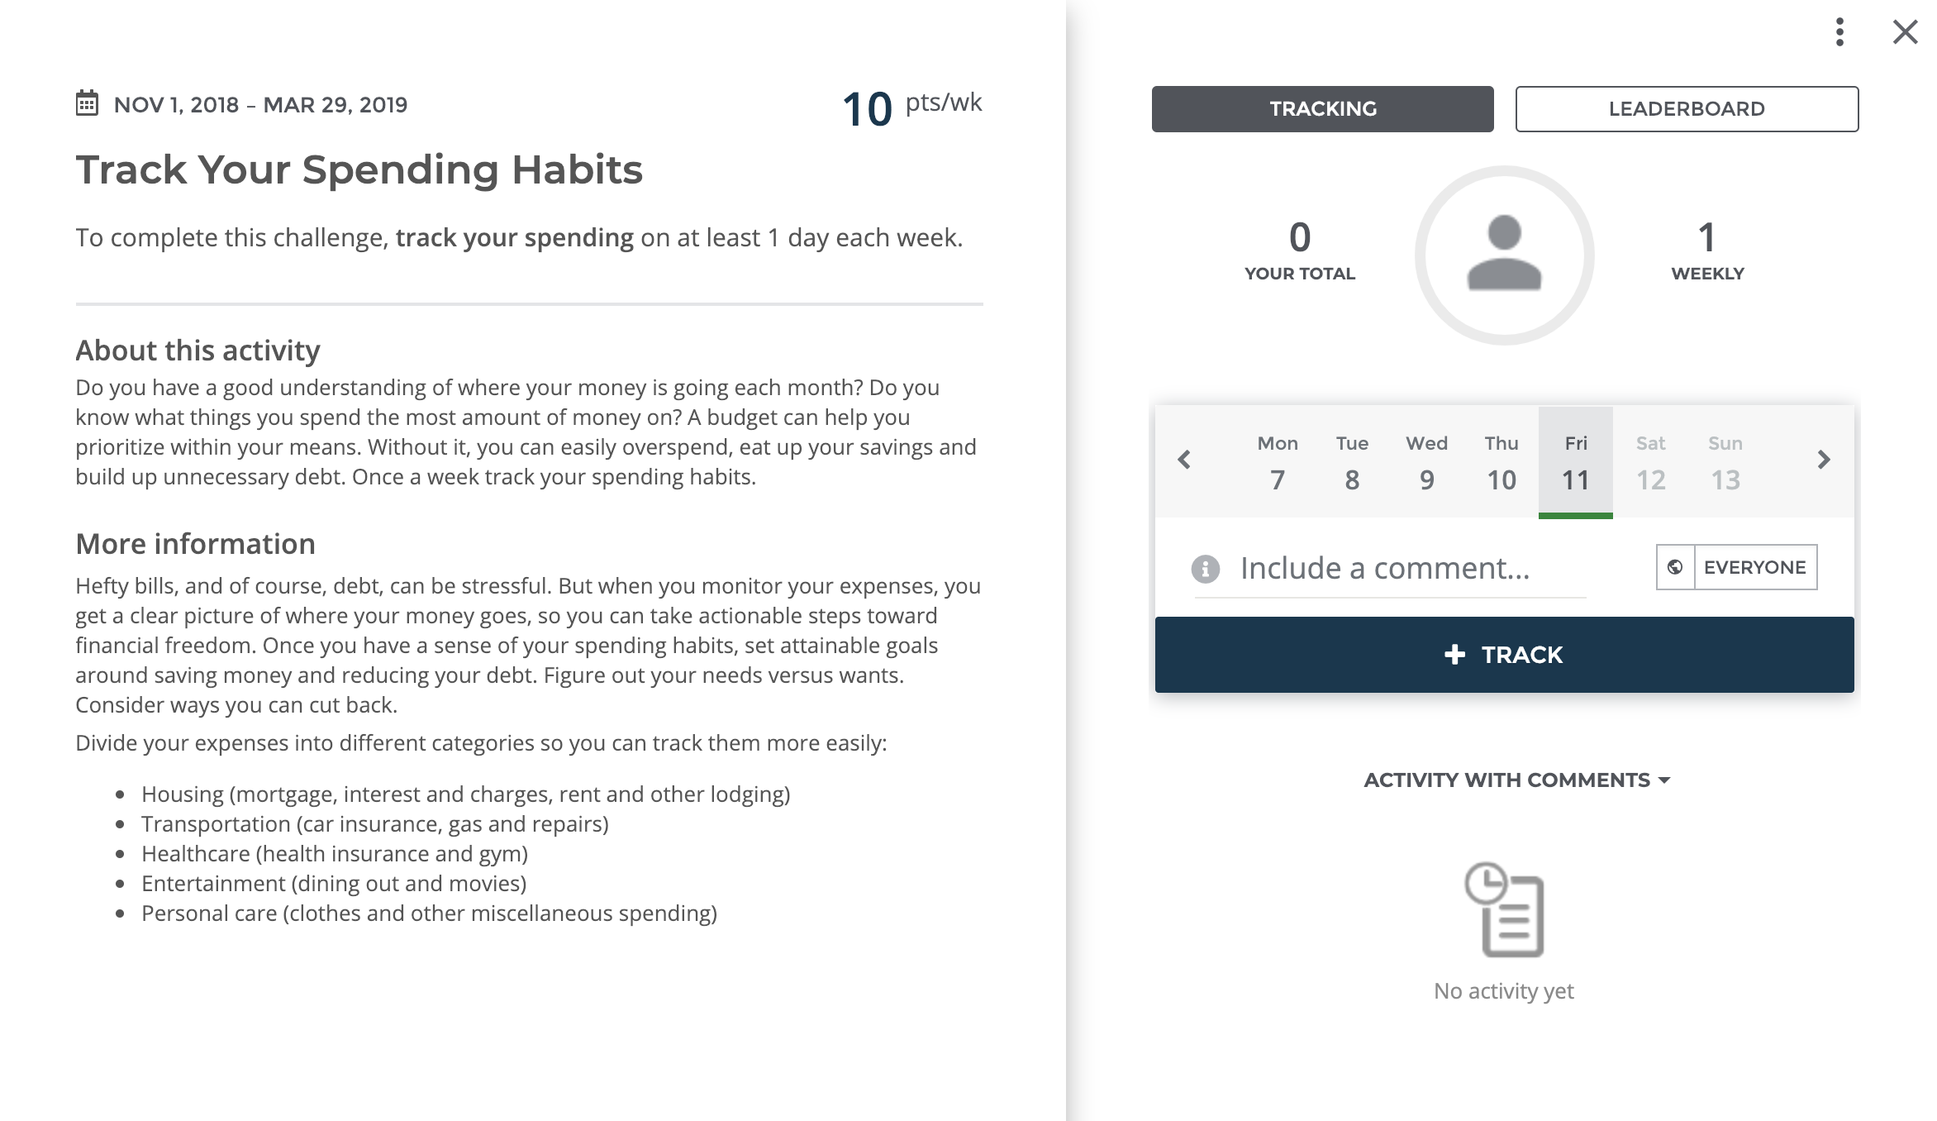
1
2
3
5
4
6

KEY

1 | Dates
2 | Activity Title
3 | Tracking Details & Completion Requirements
4 | Short Description
5 | Long Description
6 | Points
7 | Tracking & Leaderboard Interface (talk to your Washington Wellness consultant if you are interested in a Leaderboard for your activity)

Long description

